**Scrum Process In AGILE Methodology:**

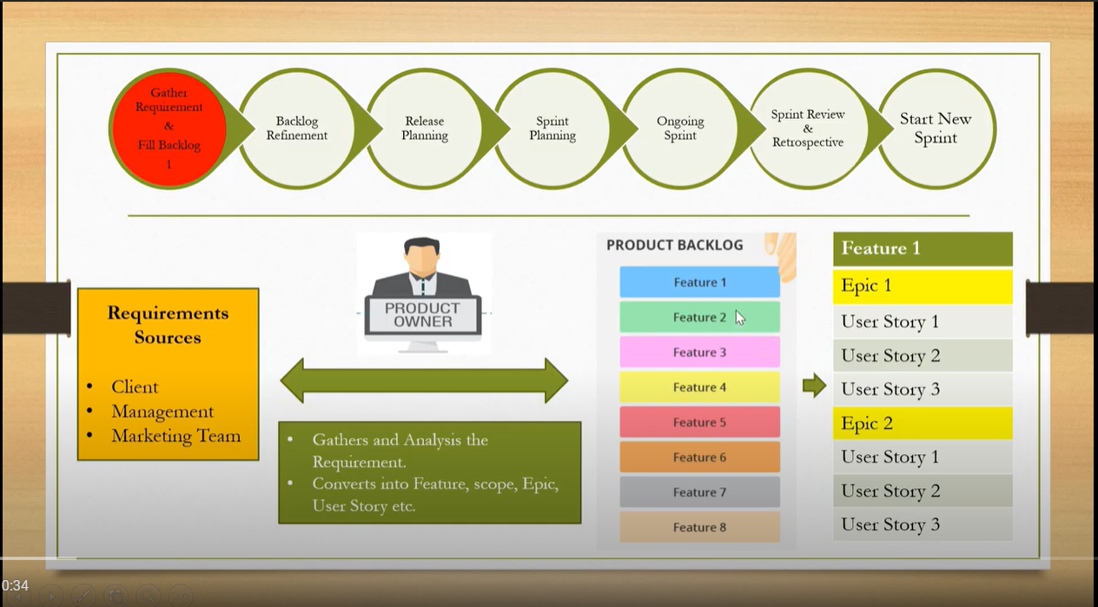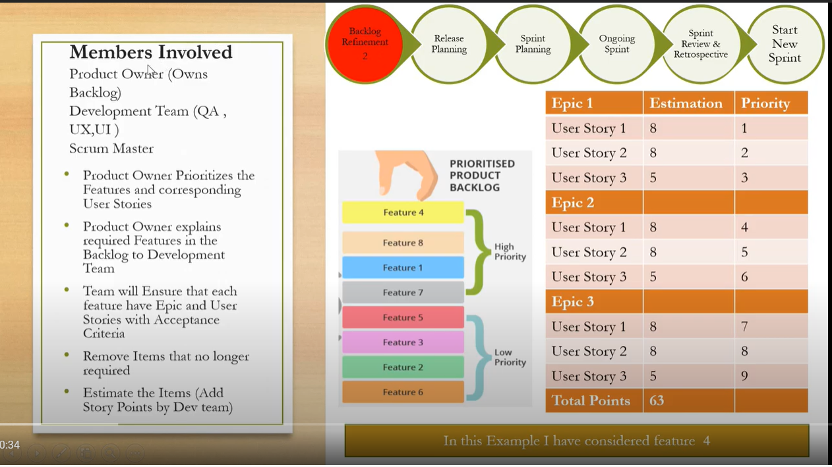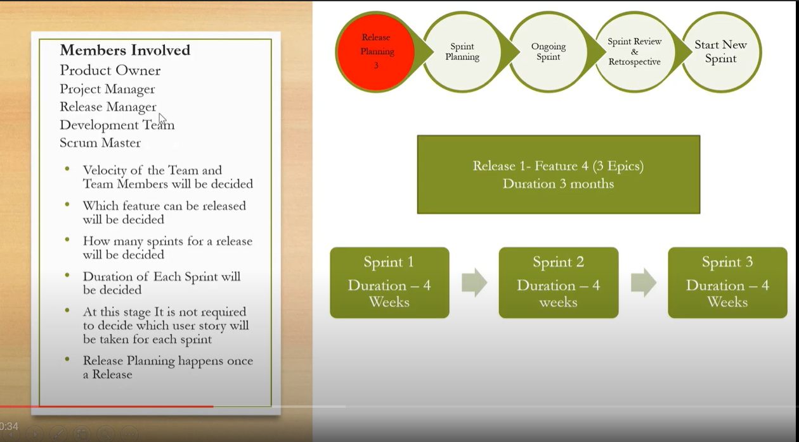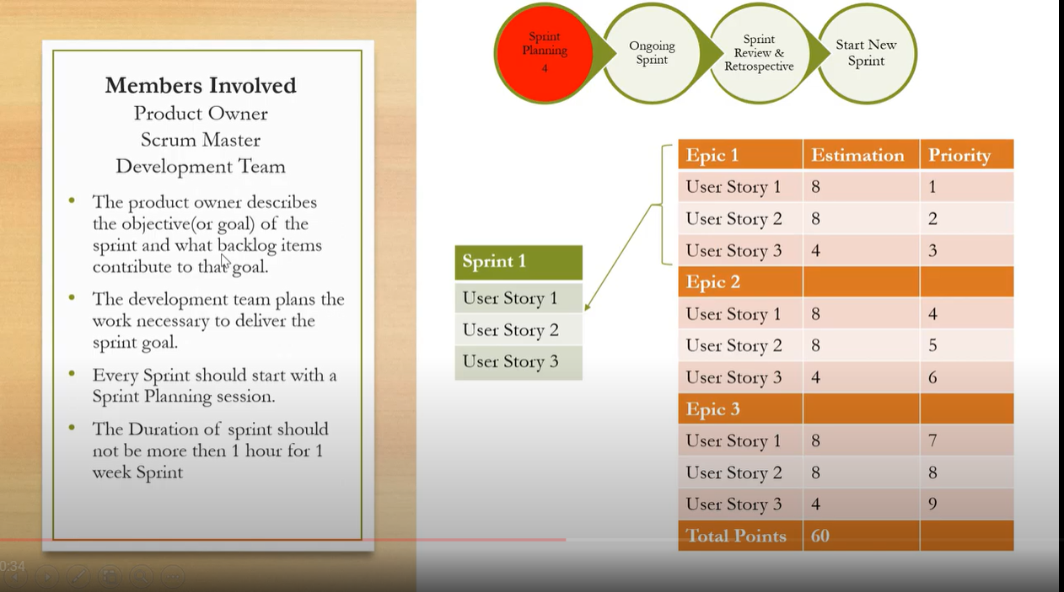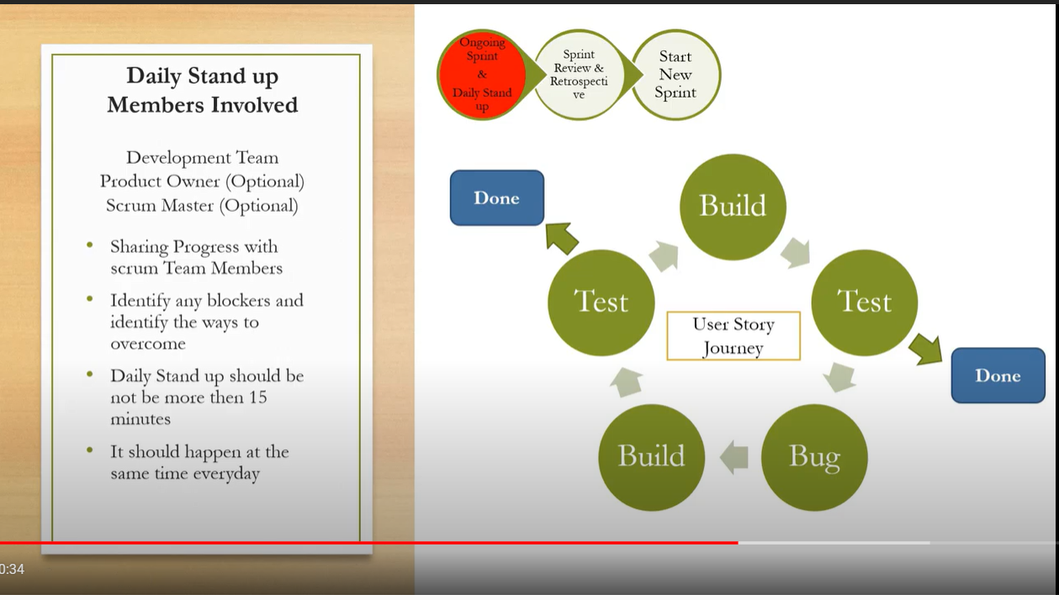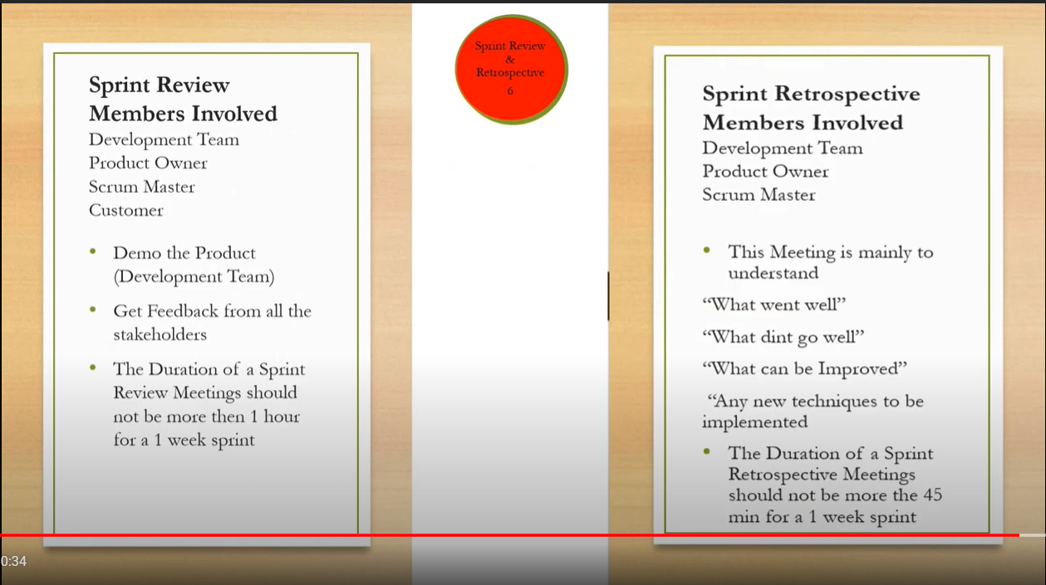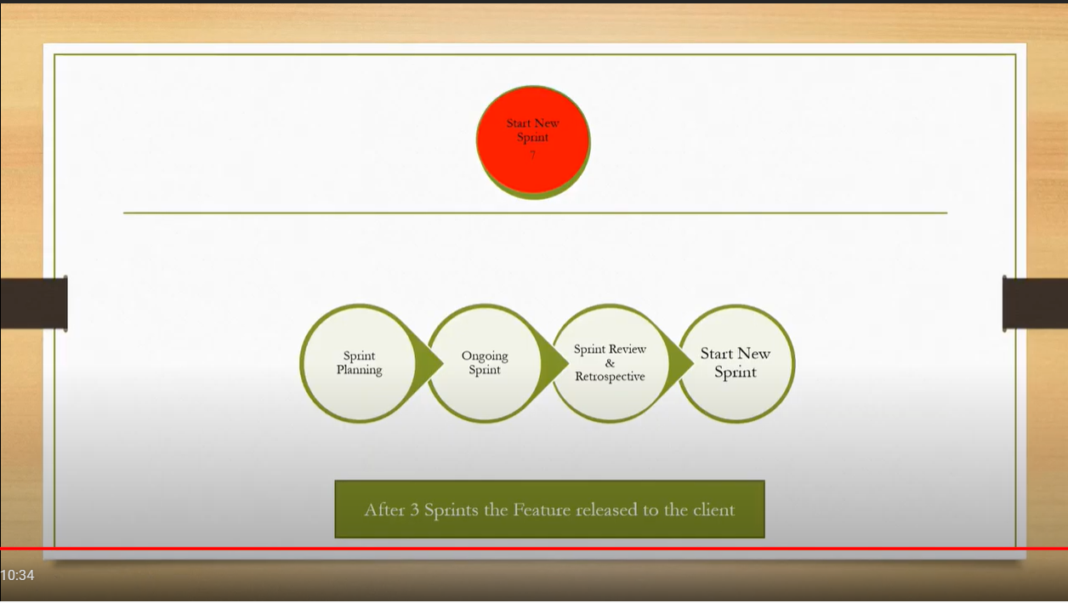

Jira is a software application used for **issue tracking and project management**. The tool, developed by the Australian software company Atlassian, has become widely used by agile development teams to track bugs, stories, epics, and other tasks.

How to n where to register :

[Atlassian Account](https://id.atlassian.com/login)

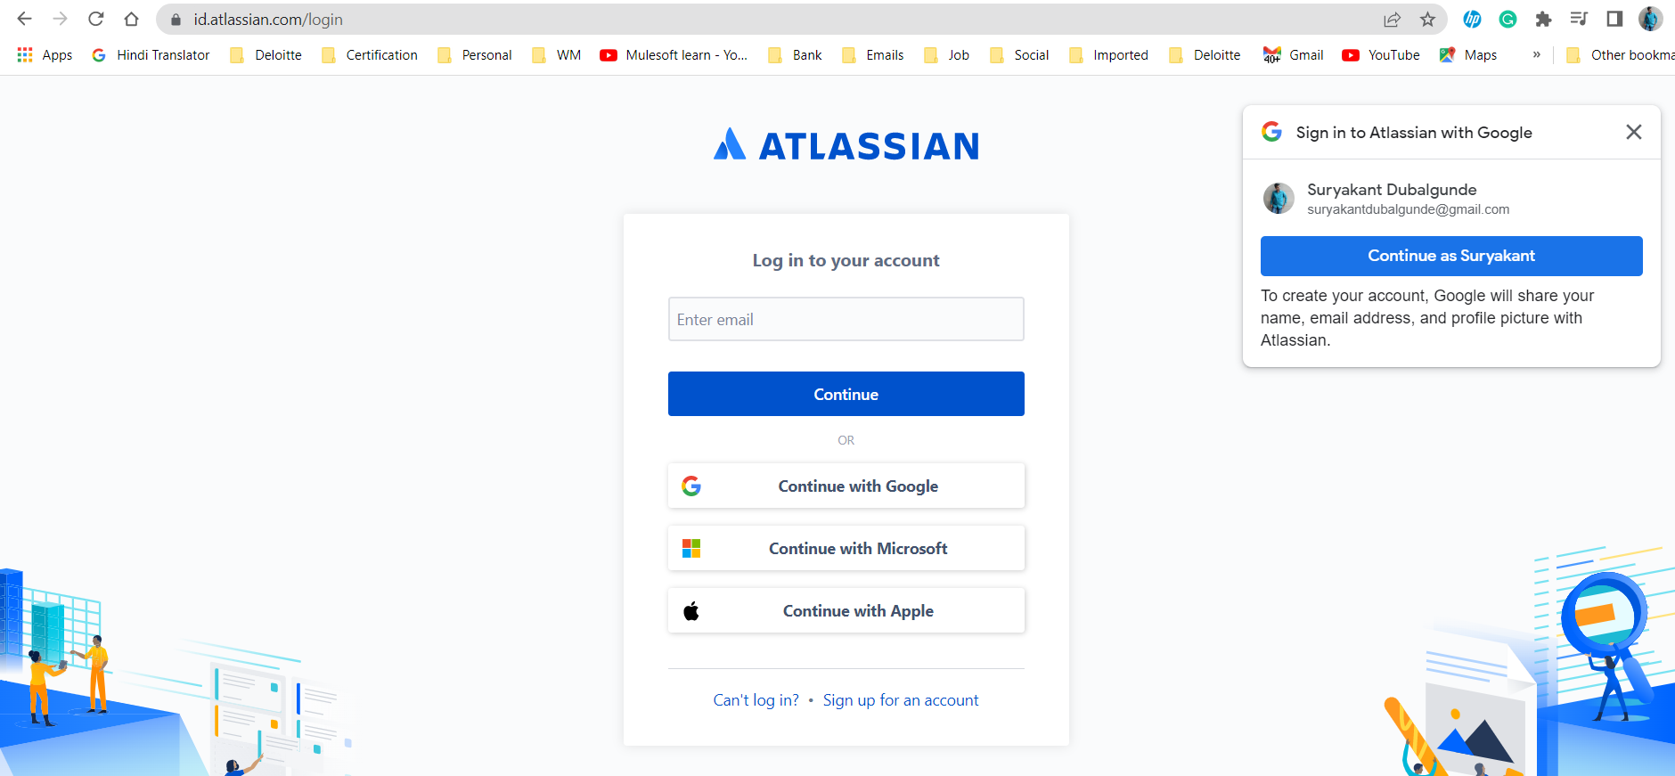

**Breaking Down Initiative/Feature Epic and User Story**

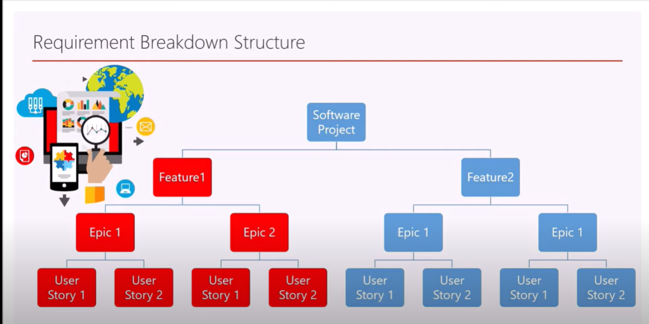 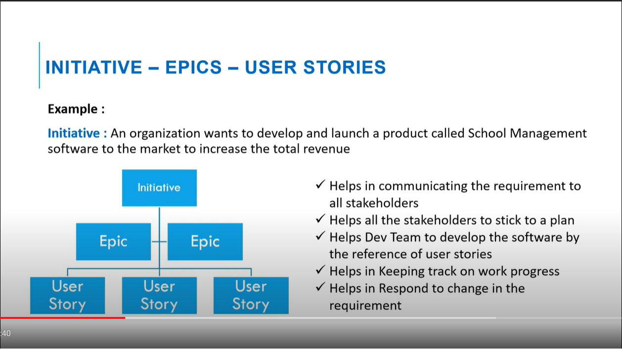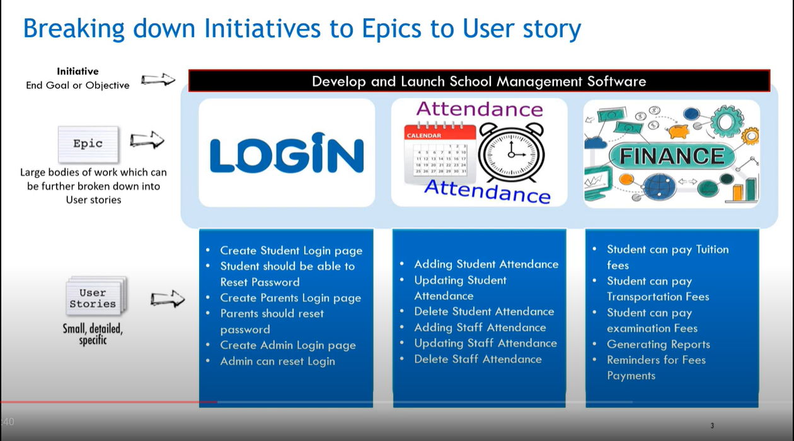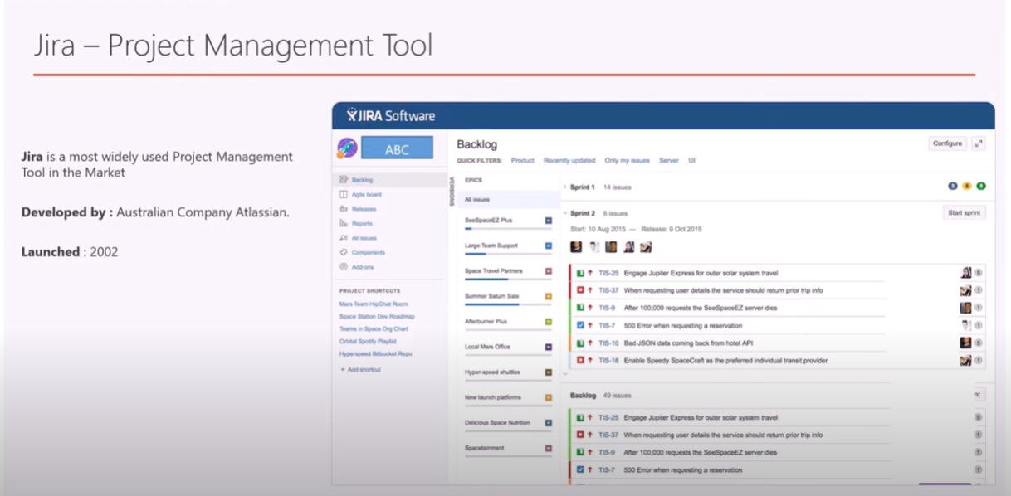

**Difference Between Feature, EPIC and User Story:**

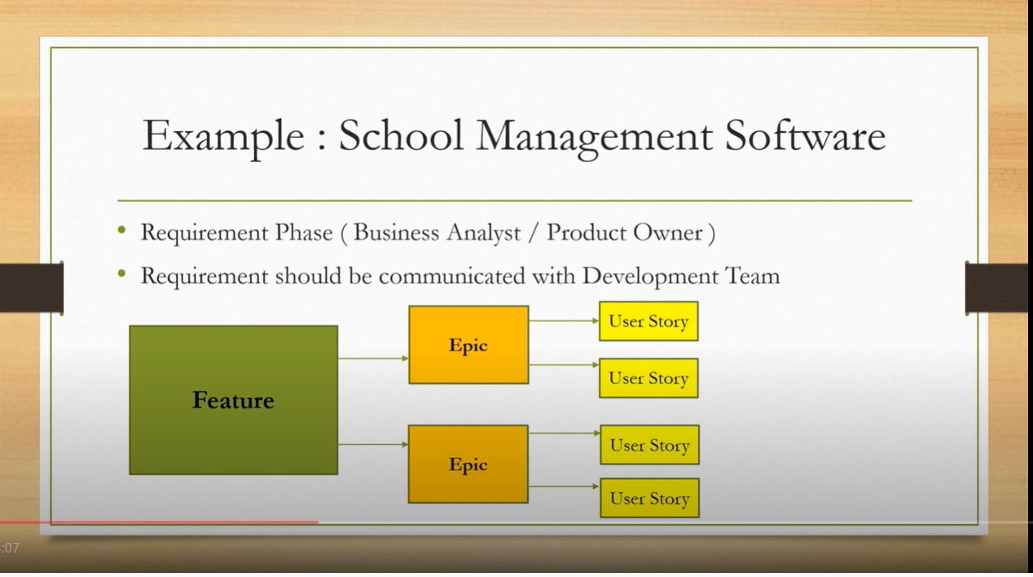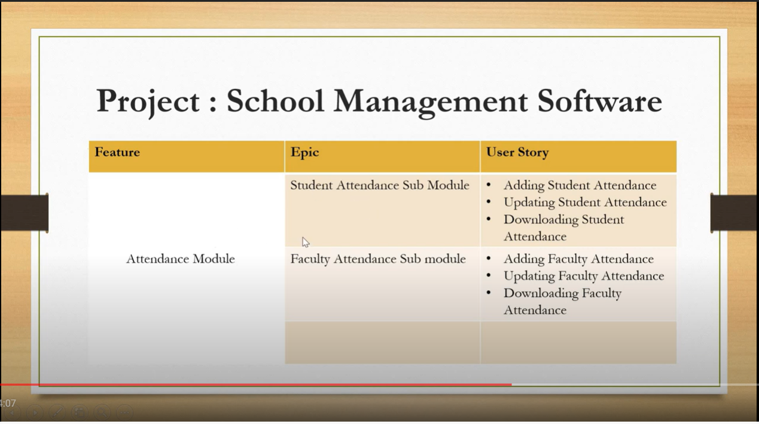

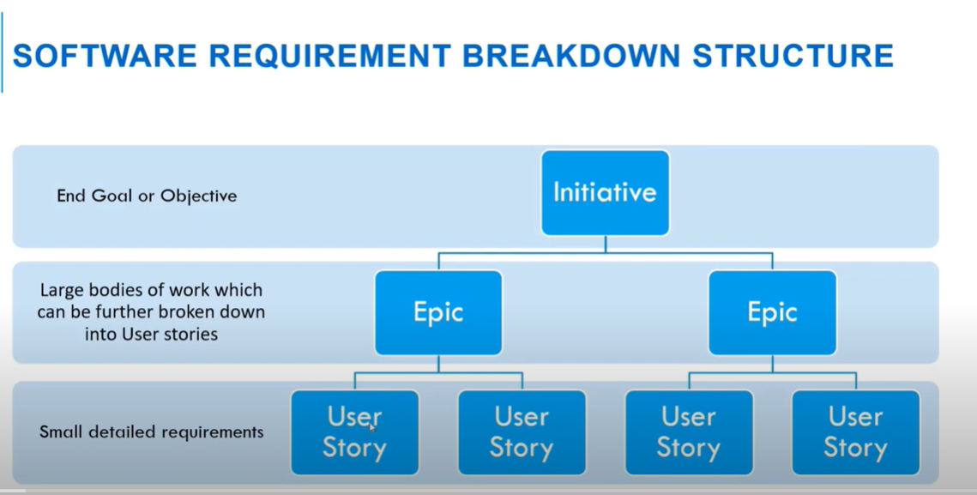 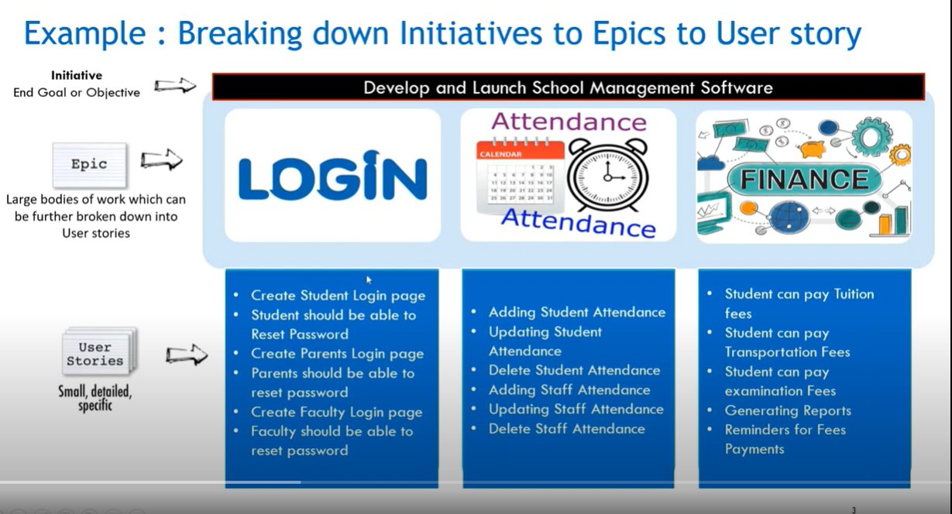

**User Story Life-Cycle in JIRA:**

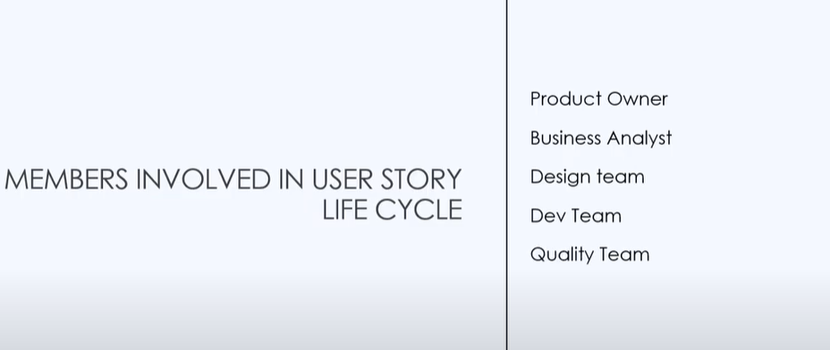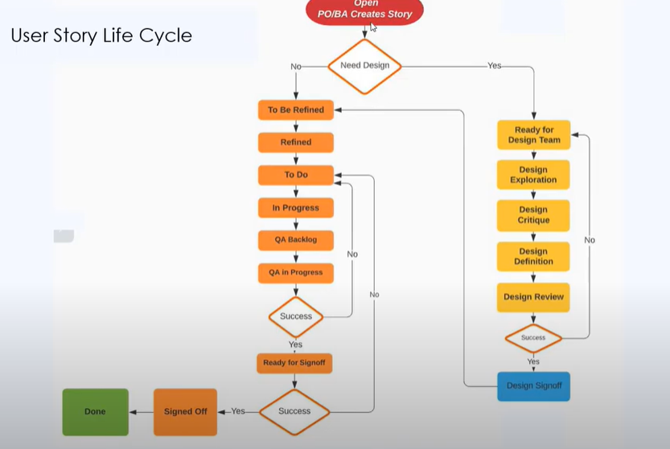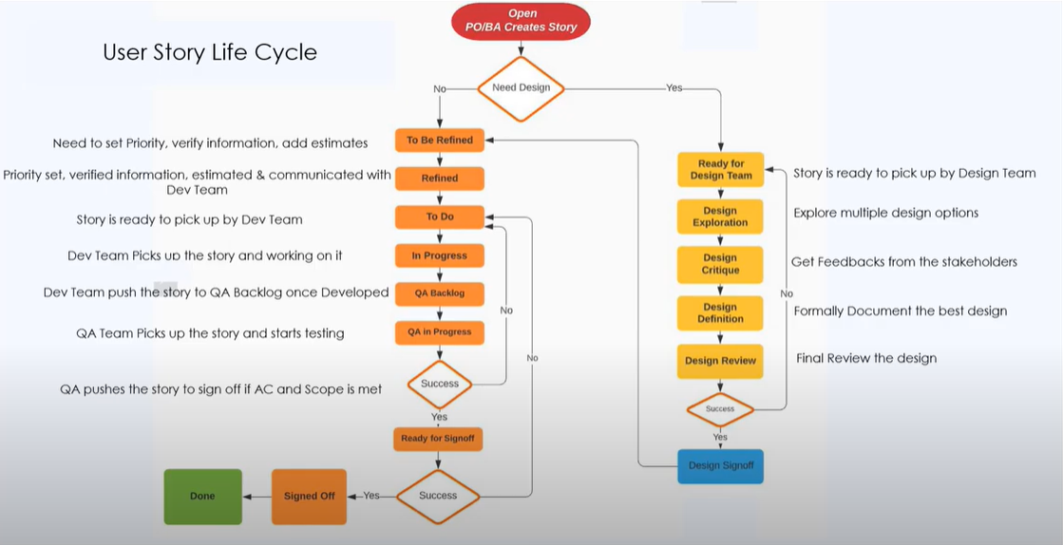

**How To Write An EPIC In JIRA:**

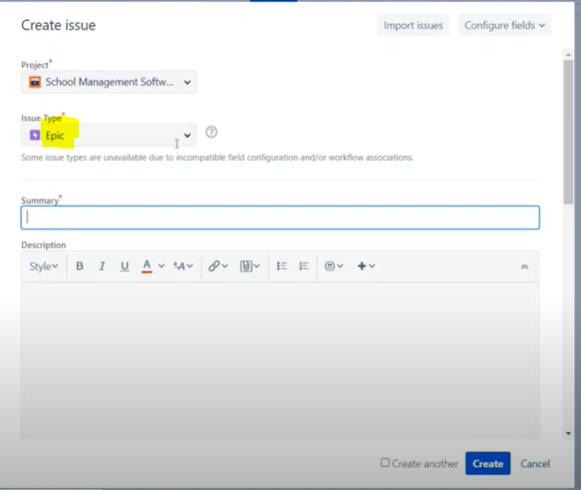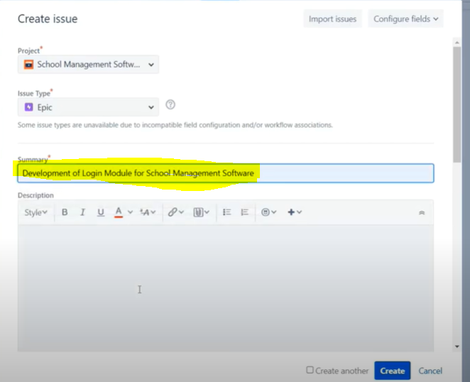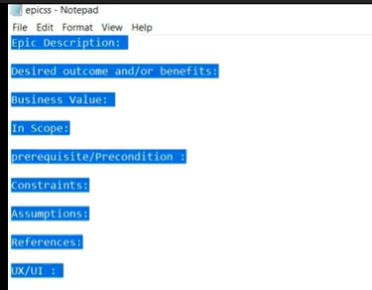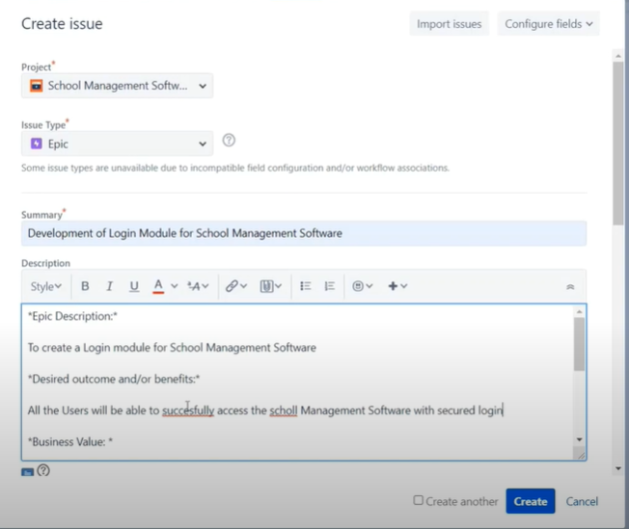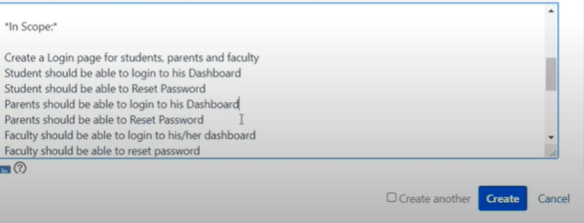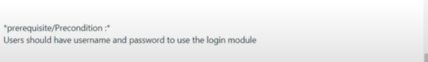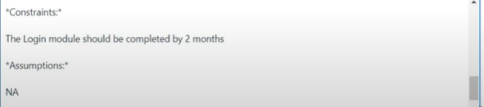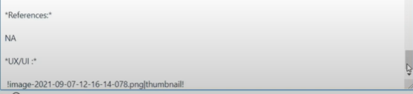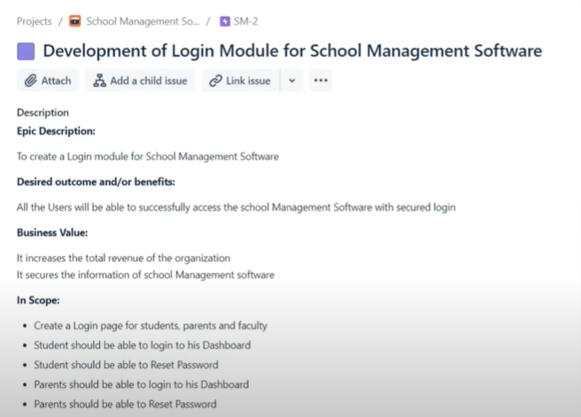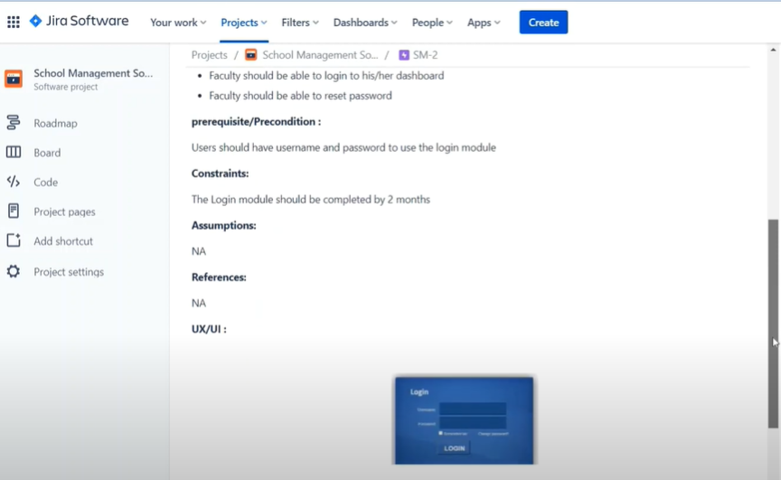

**How To Write A Story In JIRA:**

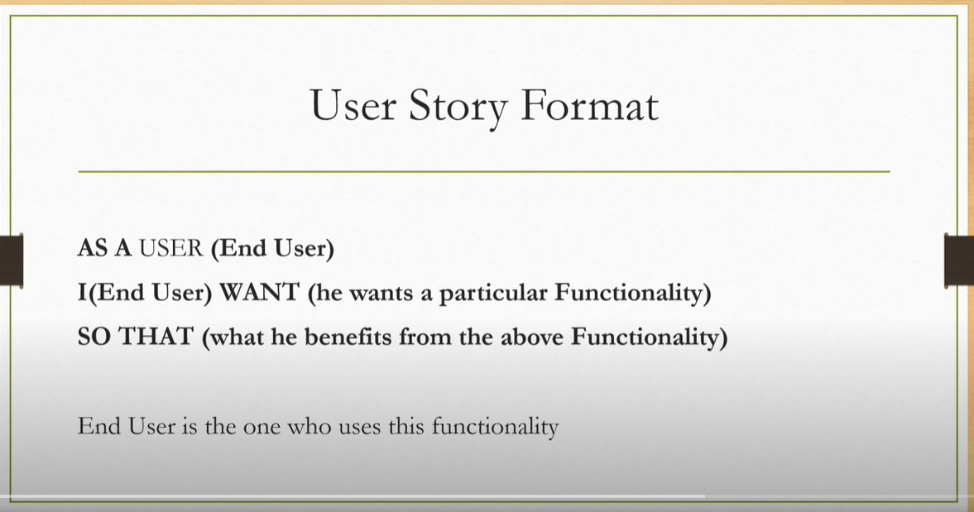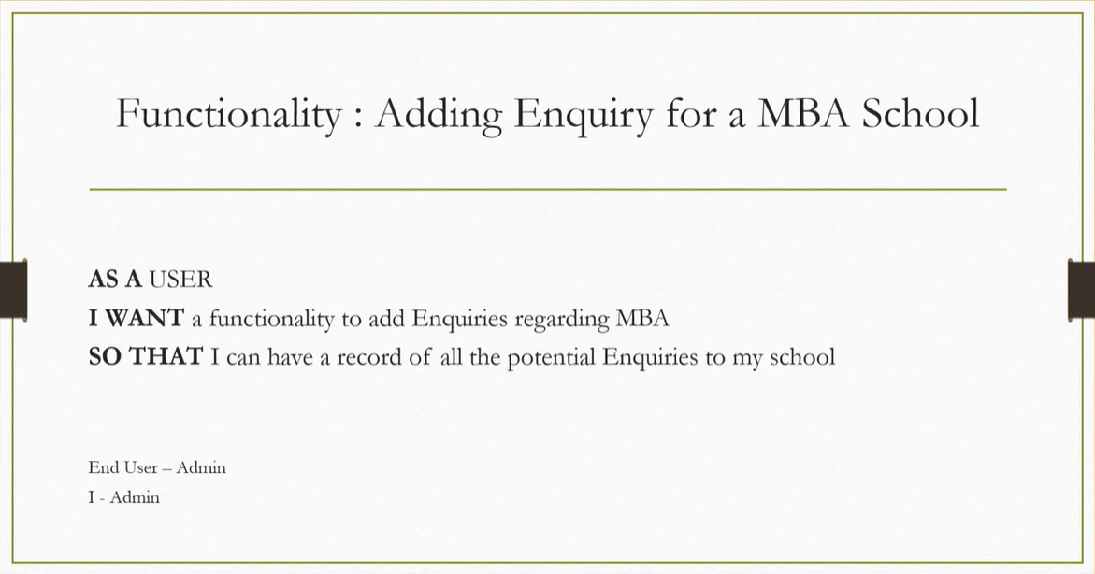

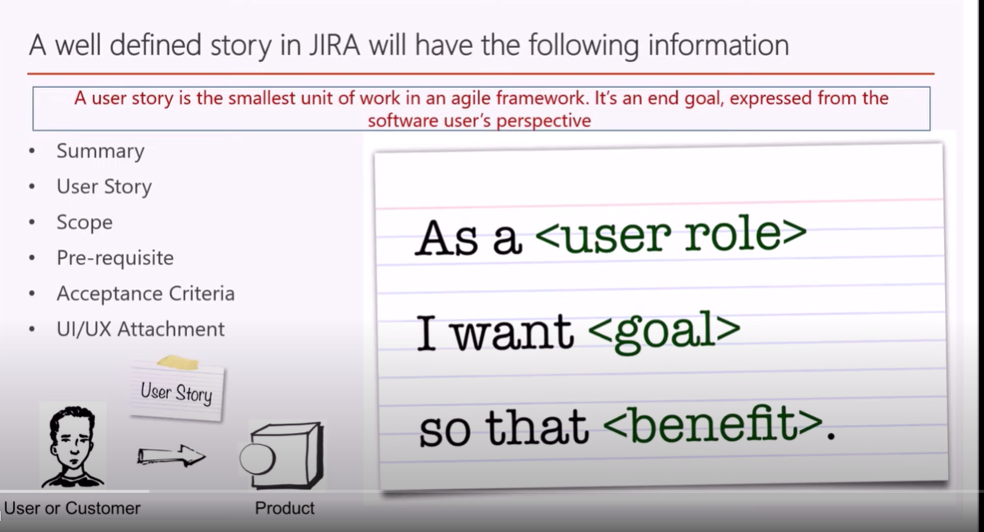

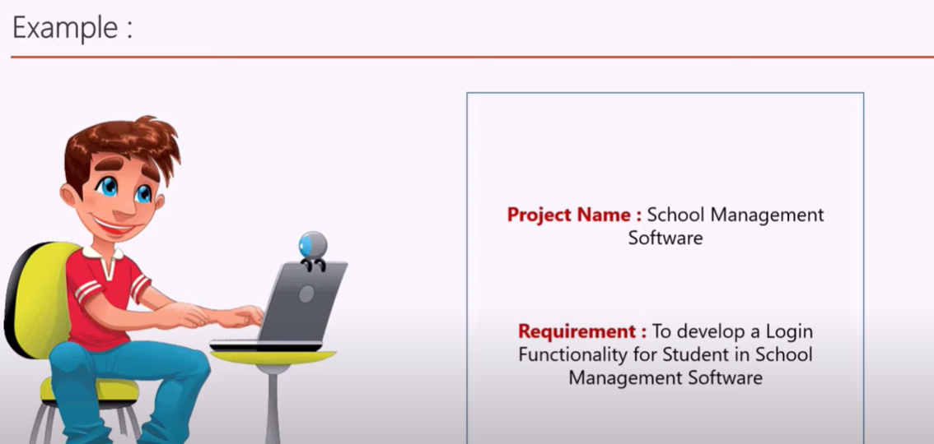 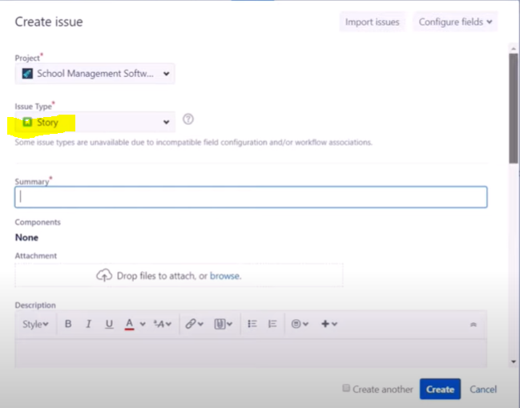 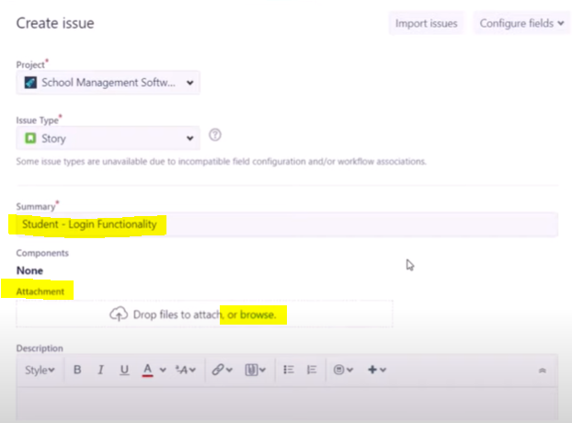 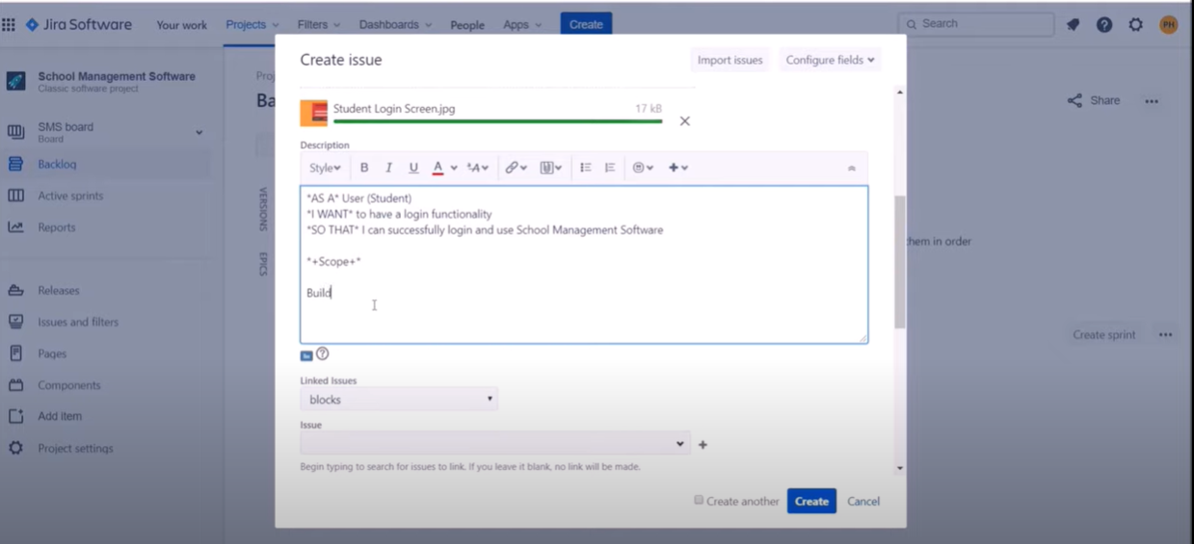 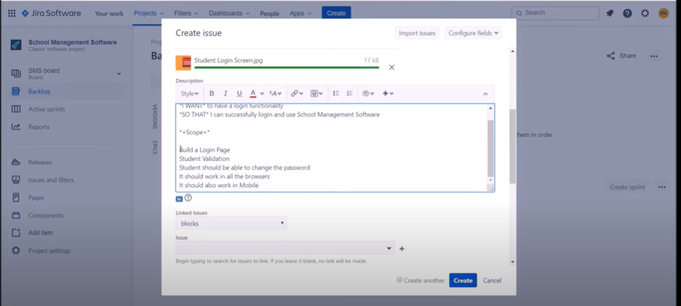 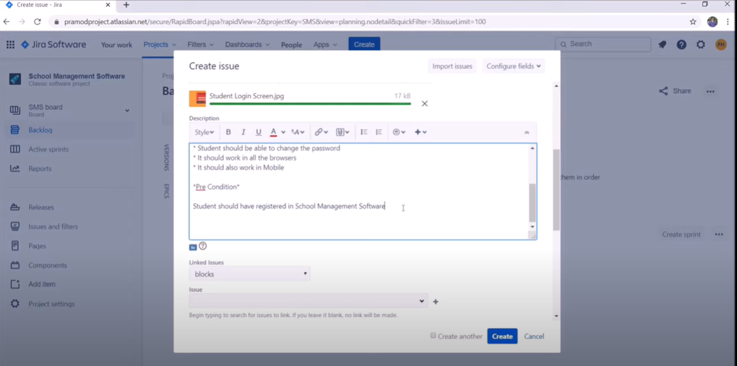 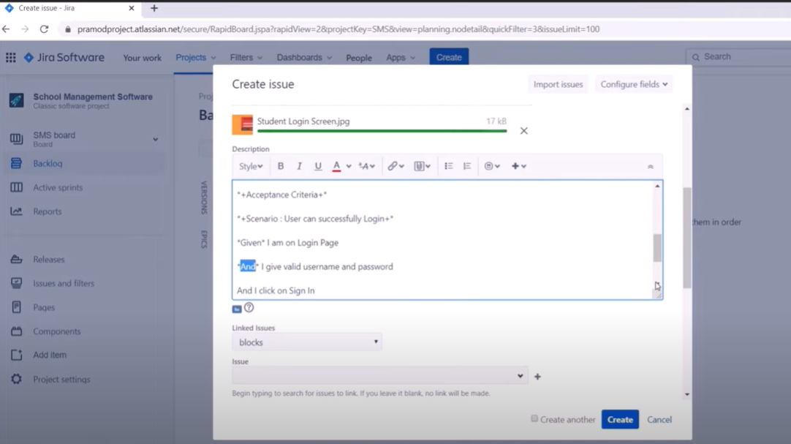 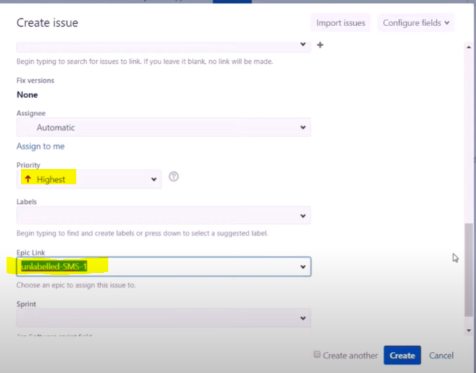

**How to write Acceptance Criteria:-**

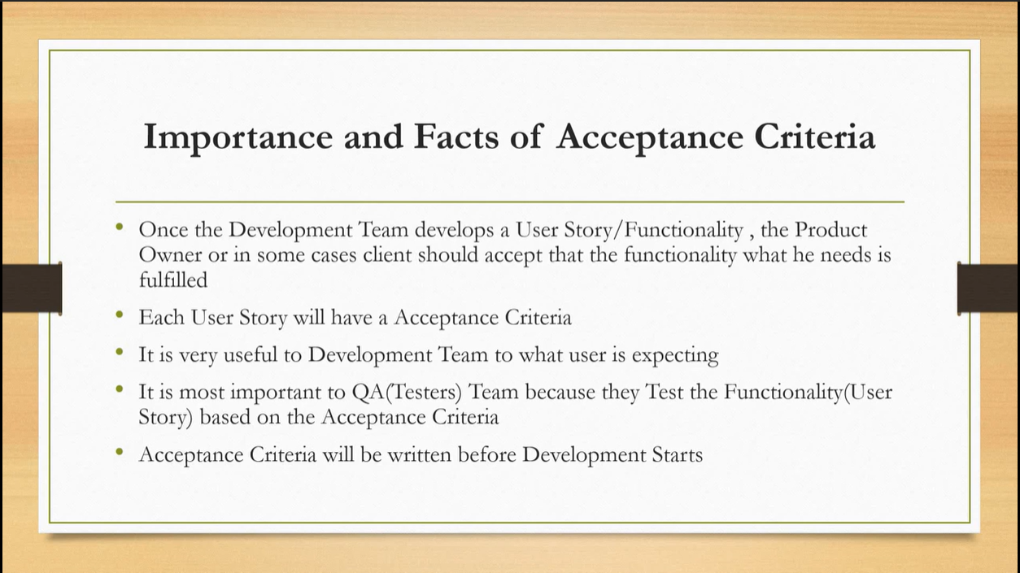

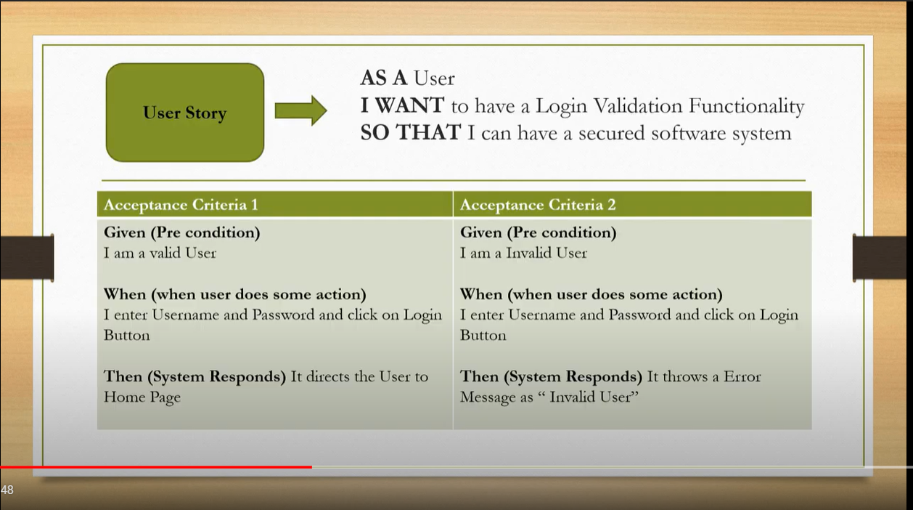

Have two templates

Scrum:Has Sprint and do not include any changes in the current scheduled changes sprint

Kanban: don’t have sprint and includes ongoing changes.

Two Types of Project:

Team Managed:the entities(bug,story,epic) created in project can not be shared outside the respective Team Managed Project.

Company Managed: entities(bug,story,epic) created in project can be shared outside the respective Managed Project

Sprint: is a time duration to complete the task

**Jira Fundamentals Course from Atlassian site** [**Jira Fundamentals-Atlassian Website**](https://university.atlassian.com/uploads/resource_courses/targets/3130587/original/scormdriver/indexAPI.html)

Course points go here down**…🡪**

-Jira is Project Mgmt Tool which is developed by Atlassian .

-Jira helps your team become more transparent, efficient, and collaborative.

-There are  different Jira products. Info given below

1)**Jira Software** is the most popular Jira product. It is built for teams to plan, track, and ship world-class software.

**Who uses Jira Software?** Any type of team can use Jira Software, but it's mostly used by software development teams.

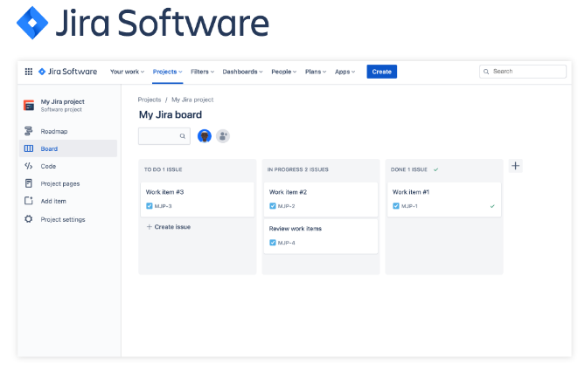

2) **Jira Work Management** is Jira for business projects not related to software development. It helps teams manage business projects such as marketing campaigns, HR onboarding, financial approvals, and legal document reviews.

**Who uses Jira Work Management?** Business teams that are not developing software. Think marketing, HR, operations, legal, finance. Any department in your organization can use Jira Work Management to manage their work.

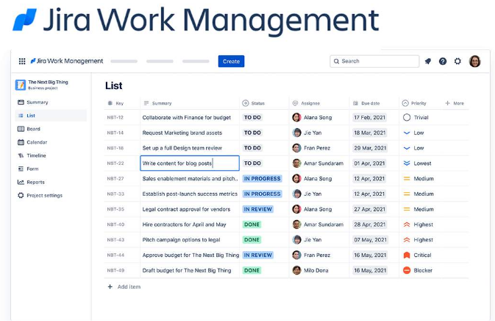

3) **Jira Service Management** is for IT ticketing and service requests. It helps teams respond quickly to service requests and deliver great customer service experiences.

**Who uses Jira Service Management?** Mostly IT Ops, Dev teams, or any other type of service-based team.

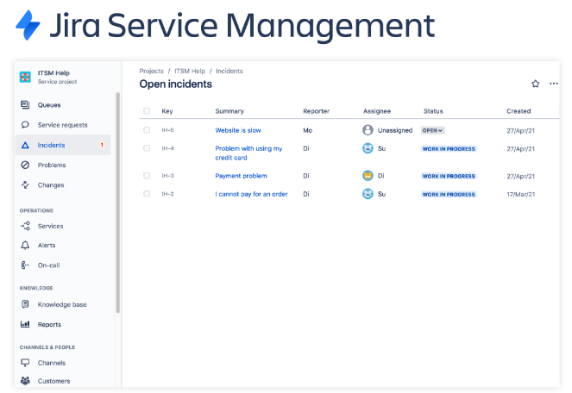

4) **Jira Align** is to help large enterprise teams unlock agility across their entire organization; connecting business strategy to technical execution.

**Who uses Jira Align?**Mostly large enterprise organizations.

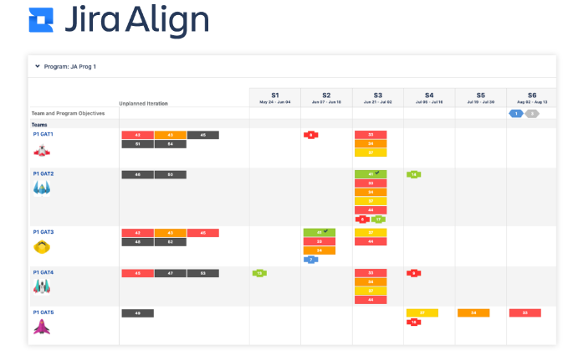

- **Jira is a tool to help your team manage work.**

**Think of Jira like a to-do list for your entire team.** It helps everyone on your team track their work items and make sure they deliver on time.

**The Jira product family is for all types of teams.** Agile software teams. Customer support teams. Marketing teams. Whether you're on a team of five or five thousand, Jira helps keep the work all in one place.

- Managing work in Jira helps your team be more **transparent, efficient, and collaborative.**

**Transparency** means everyone on your team can see what work is getting done. **Efficiency** means your team can plan ahead by knowing exactly when work will start and end. **Collaboration** means working closely with your teammates, keeping discussions and comments well-organized

- it helps you:

✅  **Prioritize** your most important work items

✅  **Improve your efficiency** of getting work done

**✅  Better plan your week** by visually seeing upcoming work

✅  **Find answers and ask questions** about your work items

✅  **Stay in the loop** on your team's work

Jira is a tool your team has chosen. It's here to help everyone on your team be better at their jobs. **Like any tool, you can use it to your advantage to improve your own performance and ultimately, boost your own career.**

**Jira Roles**

-There are two main roles in Jira: **users**and **administrators.**If you're taking this course, you're probably a user. That means you'll use Jira to track and manage your daily work.

You won't be setting up new Jira projects. Or adjusting any advanced settings. Your Jira administrator or team leader will take care of that for you.

**Jira user (probably you)**

**How they use Jira:**

✔ Update their assigned work items

✔ Share progress with their team

✔ View their team's progress on work and provide feedback

**Jira administrator**

**How they use Jira:**

✔ Configure Jira layouts, features, or permissions for a team

✔ Plan resources based on bandwidth, prioritize issues across projects, and build reports to track team performance.

**As a user, what will you be doing in Jira?**

**Your main role will be to update your work items, every day.**

Jira can only help if you and your teammates consistently update your work items. In Jira, individual work items are called **issues**. Issues are very important in Jira. You'll see them a lot throughout this course.

In Jira, you'll update issues to show work progress or add relevant information.

**✔ Completed a work item?** Update the issue in Jira.

**✔ Need to ask a question?** Update the issue in Jira.

**✔ Have notes from a meeting?**Update the issue in Jira.

- 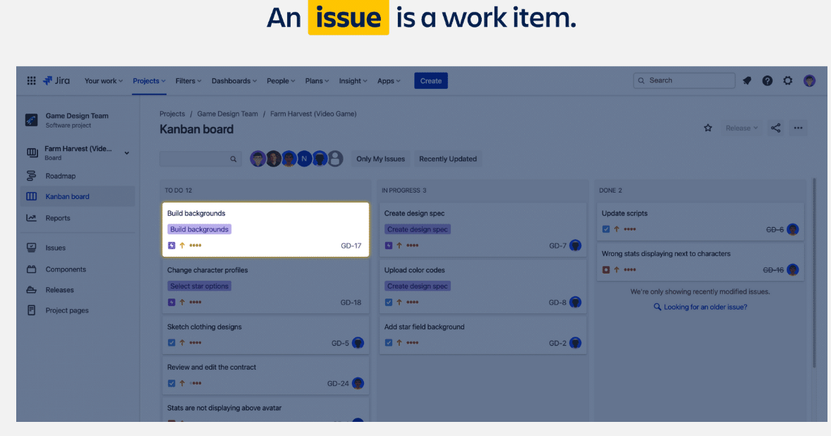

**Let's see some example issues**

**Issues can vary in size depending on how your team uses them.** Some issues take months to complete. Other issues are finished in a few hours.

👇 Check out the examples below to see how different types of teams use issues.

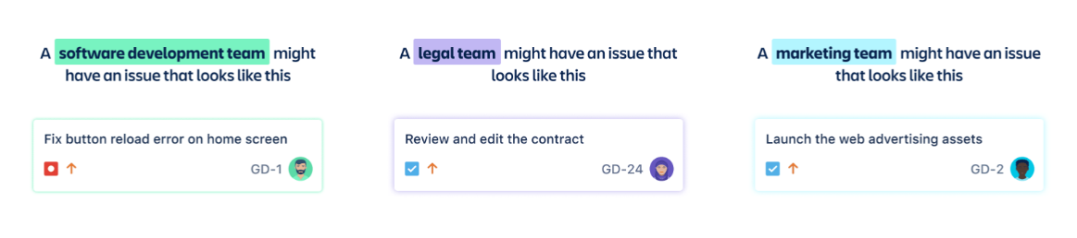

**In the examples above, look at the small profile image at the bottom right of each issue.** That profile image indicates the person responsible for doing the work and updating the issue. That's where you'll come in!

You'll learn more about issues in future courses. How to create them. How to update them. And how best to organize them. **For now, just remember what issues are: the work items you'll update to show progress or add relevant information.**

You may hear issues called 'tickets', 'requests', or 'tasks'. We recommend you use 'issues' to help keep your team on the same page.

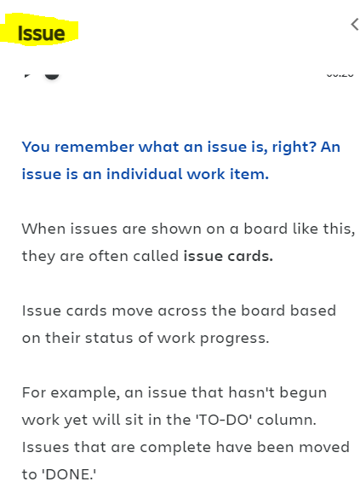

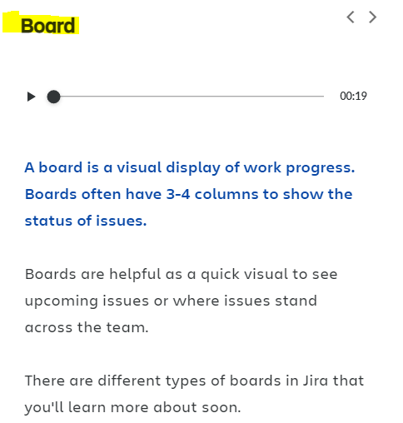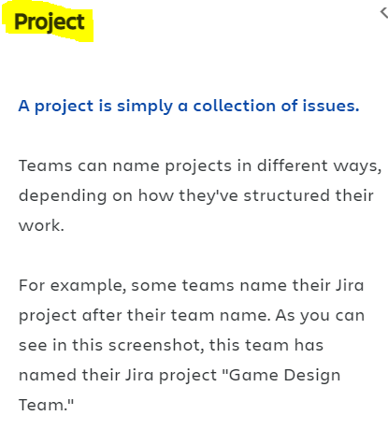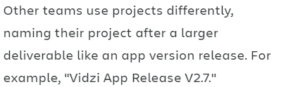

**A project is a collection of issues.**

In Jira, every single issue is attached to a project. Projects organize issues in whichever way your team prefers.

Your Jira projects will likely be set up for you. So no need to worry about creating new projects. **For now, you'll need to know how to identify your projects and what your projects are named.**

**How do you identify your projects and see their names?**

There are two ways to quickly identify your projects. **One is at the top left of your screen, under the Jira logo.** This shows the name of the project you are currently viewing. But you may be involved in more than one project.

**To see all of your projects, find the main navigation bar and select the 'Projects' dropdown.**This will show you a list of all the projects you have access to view.

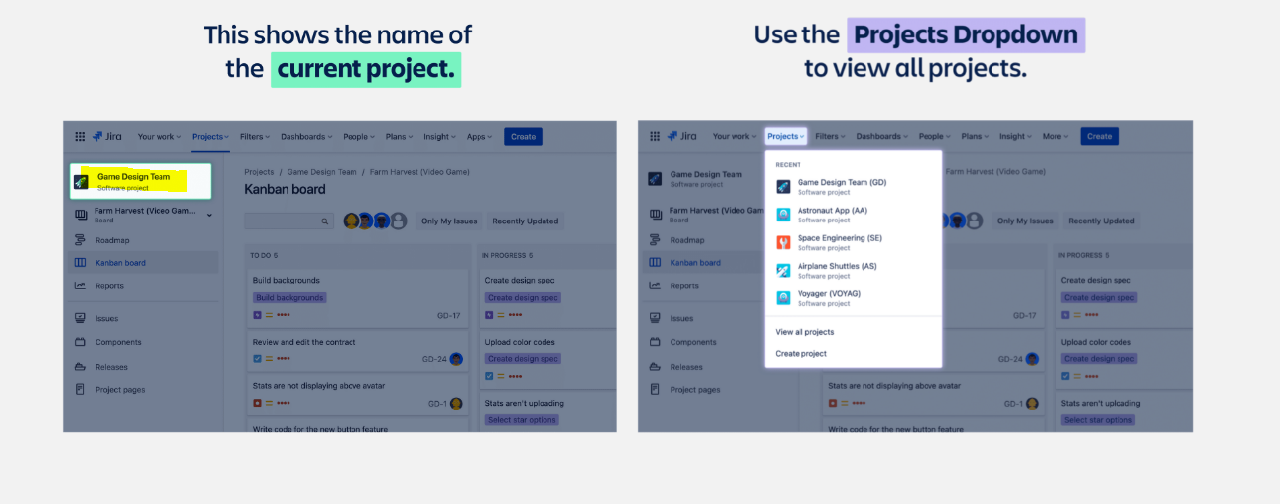

**How are projects named?**

**That depends on how your team has structured your work.**

**Sometimes projects are named after an entire team.** For example, "Game Design Team" or "Marketing Team" or "Legal Team."

**Other times, projects are named after a larger deliverable like an app version release.** For example, "Vidzi App Release V2.7" or "Project Melon Web Launch."

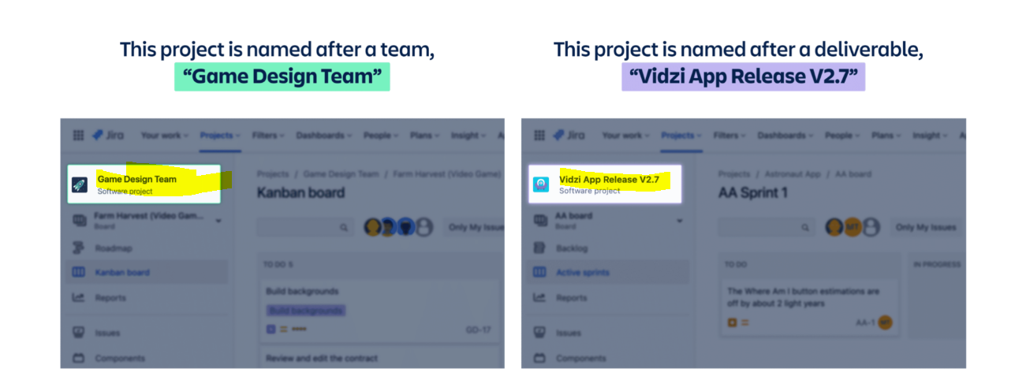

**Why should you care about project names?**

**Project names help you see how your team is structuring work.**Is your project named after your team or after a deliverable?

Knowing how your project is named will give you insight into how the work is being structured. And it will help you understand how best to use Jira for your own needs.

**👉 For example:** if your project is named "Game Design Team," you'll know that any issues within the project are related to the game design team as a whole. If your project is named "Vidzi App Release 2.7," you'll know that any issues within the project are related to that one specific deliverable, the next release of the Vidzi app.

**Boards are the most common way to see your work.**

You got a sneak peek of  **boards**earlier. **What's a board, again?**A board is a visual display of work progress, often with 3-4 columns.

These board columns have headers at the top representing the **status** of each issue. For example, statuses could be: *To Do, In Progress, In Review, Done.* Statuses are customized by each team, so yours may look different from the examples.

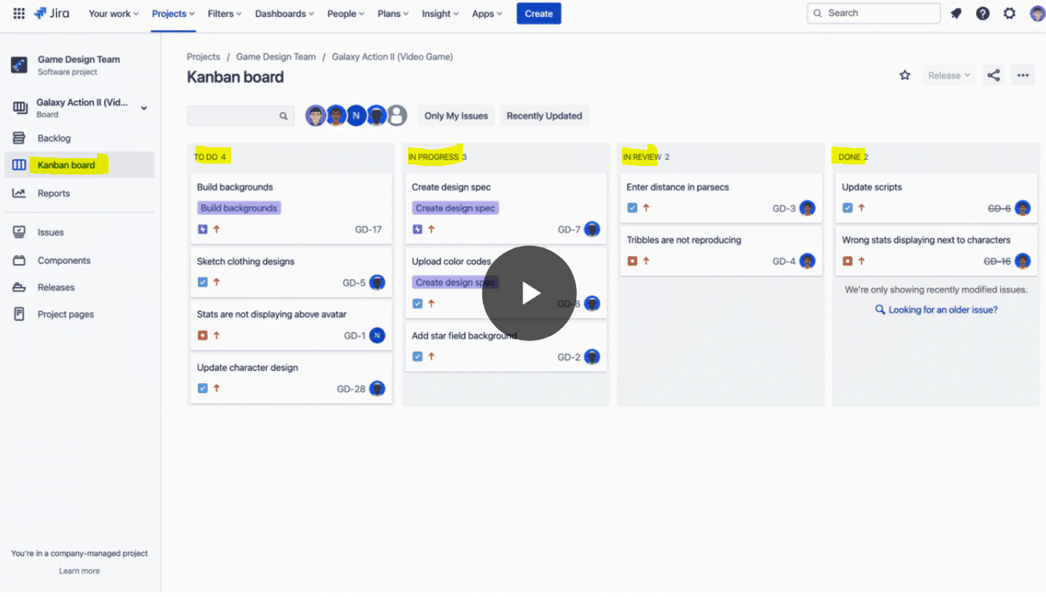

**Move issue cards across the board as work gets done.**

The different status columns together represent a **workflow**. A workflow is the path of statuses an issue will go through from start to finish. An example of a simple workflow is an issue moving from ***To Do****to****In Progress****to****Done.***

When an issue is ready to be updated, the person responsible for the work can simply *drag-and-drop* the issue card to a different column on the board. This updates the issue's status so everyone on the team can be in the loop. Issues can move forward and backward in a workflow, depending on how the work gets done.

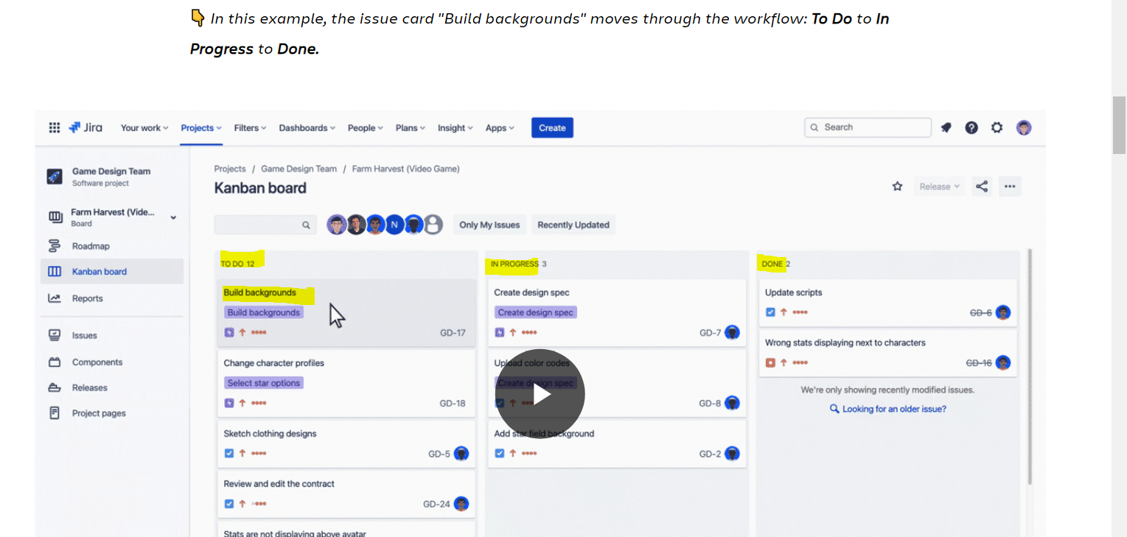

**There are two types of boards in Jira**

**Kanban boards and Scrum boards.**

The example screens you've seen so far have shown a **Kanban board**. Kanban boards are used by all types of teams. They illustrate a continuous flow of work. Issues continuously move in and out of the board from the start of the project until the end of the project.

**Scrum boards** are mostly used by agile software development teams. Scrum boards bring in groups of issues that the team will attempt to complete during a fixed period of time, often a two-week "sprint." After a sprint is completed, a new scrum board is created for the next batch of issues in the project.

**Want to know more about agile and scrum? Click here.**

–

**What is agile?**Agile is a project management methodology. It takes an iterative approach to managing projects, focusing on continuous release that require regular updates based on feedback. Agile helps teams increase delivery speed, expand collaboration, and better respond to market trends. Learn more about agile [here.](https://www.atlassian.com/agile/project-management)

**What is scrum?**Scrum is a specific agile project management framework to help design, develop, and deliver complex products. It's mostly used by software development teams. Scrum teams organize their work in sprints. A sprint is a short, fixed period when a scrum team works to complete a batch of issues. Learn more about scrum [here.](https://www.atlassian.com/agile/scrum)

**How are agile and scrum different?**Agile is a broad project management philosophy with a core set of values and principles. Scrum is one specific agile framework, a way of using those principles to get actual work done.

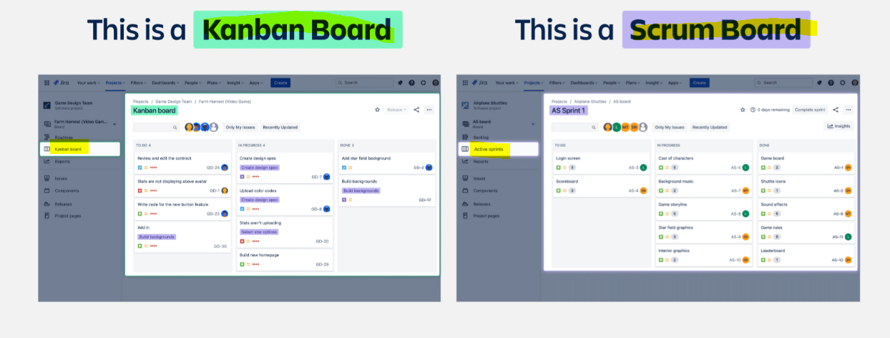

**How are boards named?**

**Just like projects, boards have specific names.**

Boards sit within projects. A single Jira project can have several boards. A board is often named after a larger deliverable or team of people.

In this example, you can see the ***project name is "Game design team"***(the name of their team). And the ***board name is "Farm Harvest (Video Game)"***(a larger deliverable).

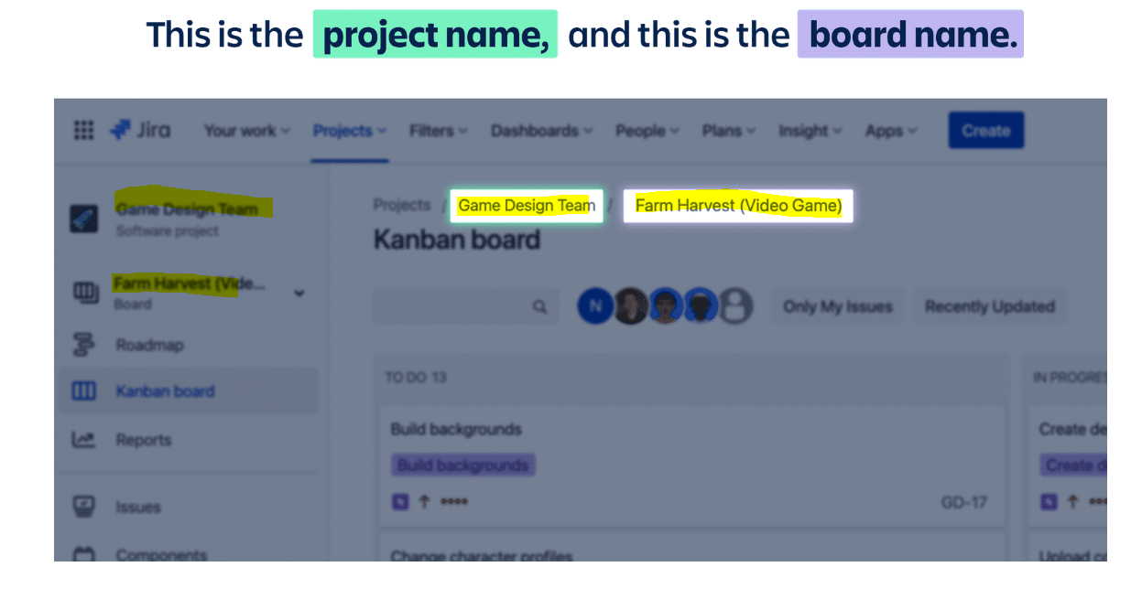

**How do you see all of your boards?**

You probably have more than one board. Each Jira project often has multiple boards within it. **To see all of your boards, navigate to the left project sidebar and select the board dropdown.**

👇 *Look at the example screen to see how this works. In this example, the team has multiple boards within the "Game Design Team" project. Their boards are named after different games (deliverables) they are working on: Farm Harvest, Galaxy Action II, and Street Car Racer.*

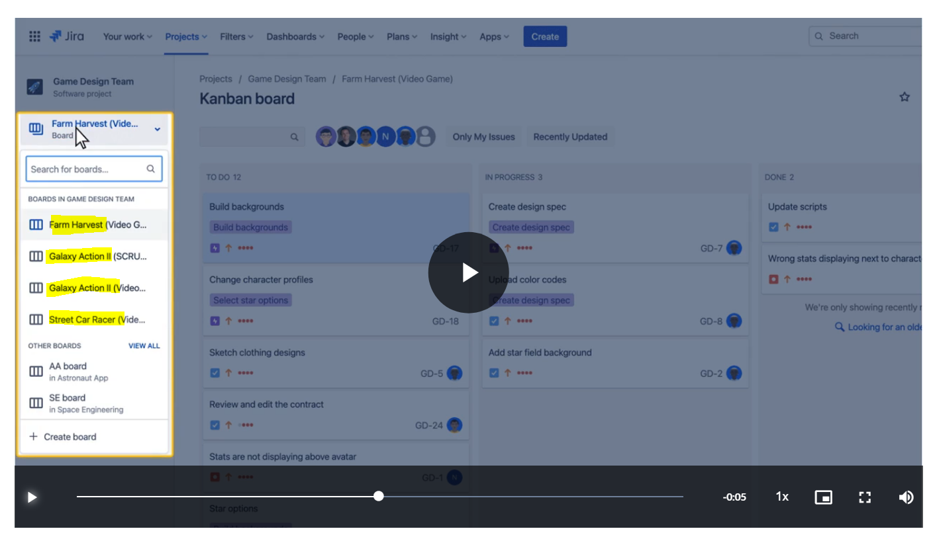

**What's the best way to get around in Jira?**

Start with these two navigation bars:

* the **main navigation bar** at the top of your screen
* the **project sidebar** on the left of your screen

At the top of your screen, the **main navigation bar**helps you find your work, projects, and teammates. It also allows you to create issues, search for work, and adjust your settings.

On the left of your screen, the **project sidebar** is a collapsible navigation bar that shows you options specific to the project you're viewing.

👇 *Click the + icons in the image below for a preview of both navigation bars.*

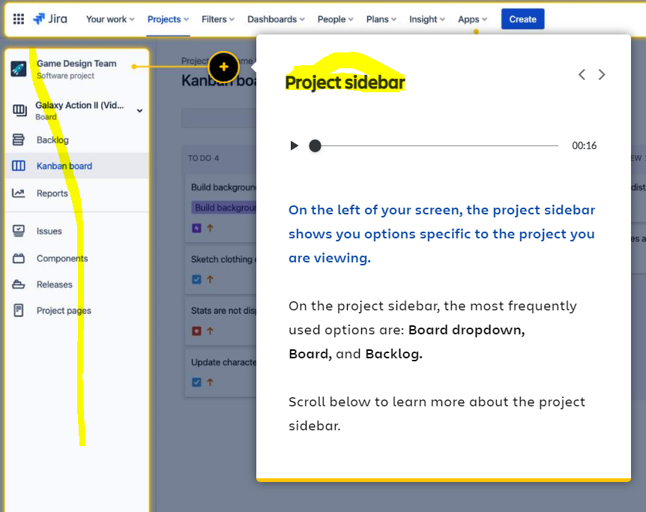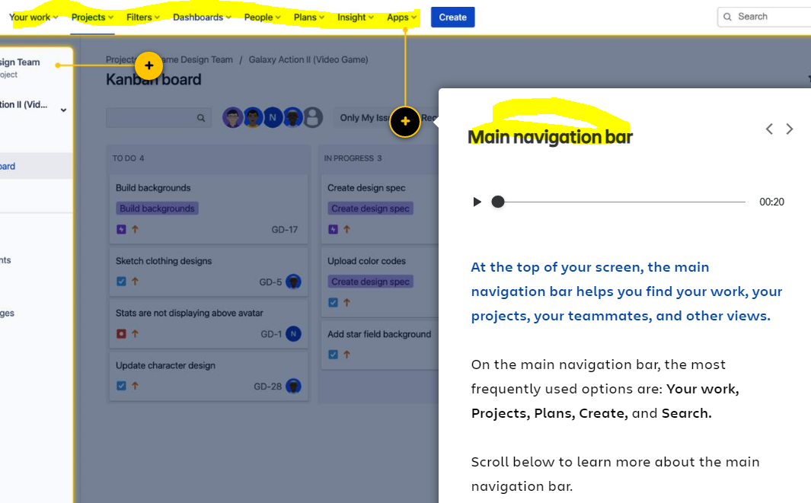

**What's in the main navigation bar?**

👇 *Click the number icons to learn about each option in the main navigation bar.*

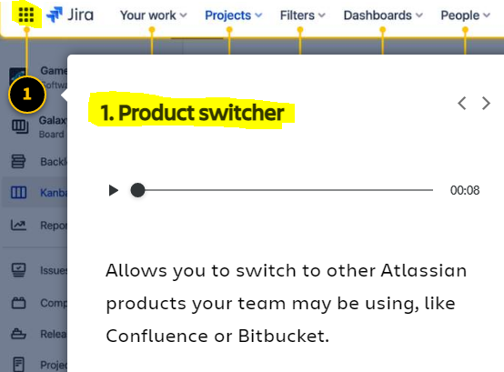

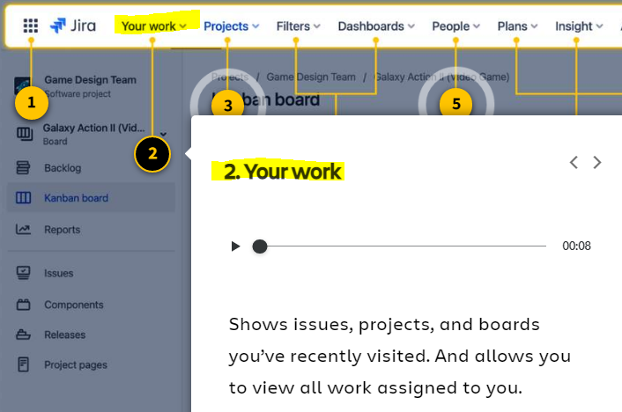

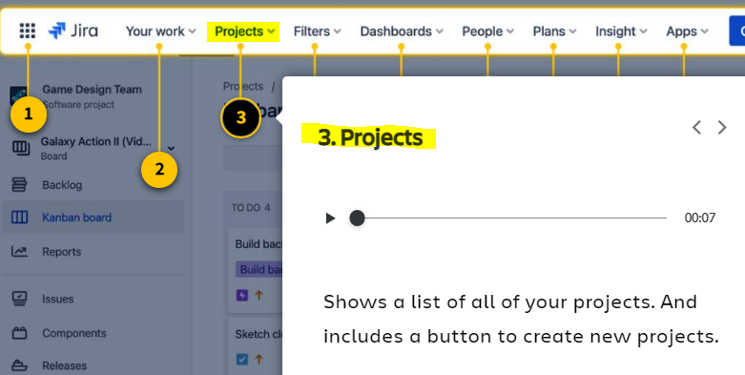

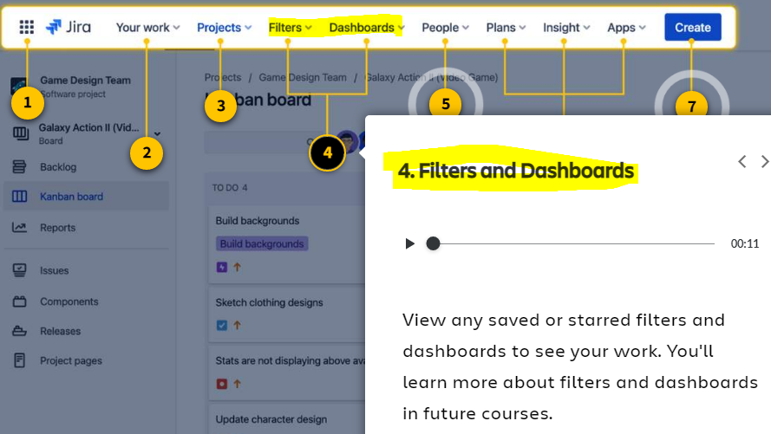

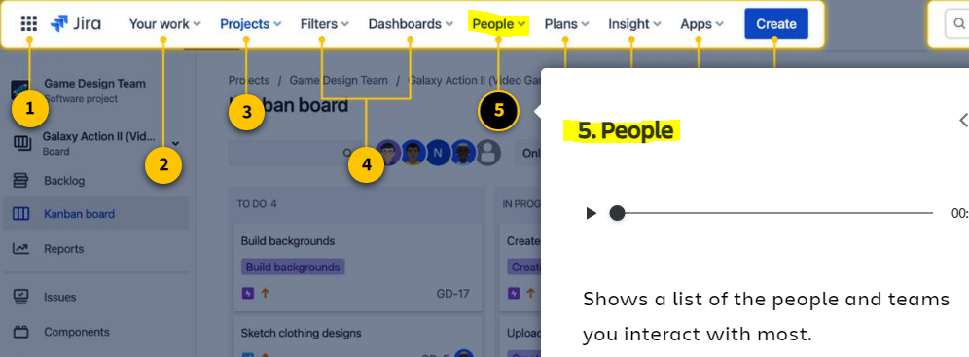

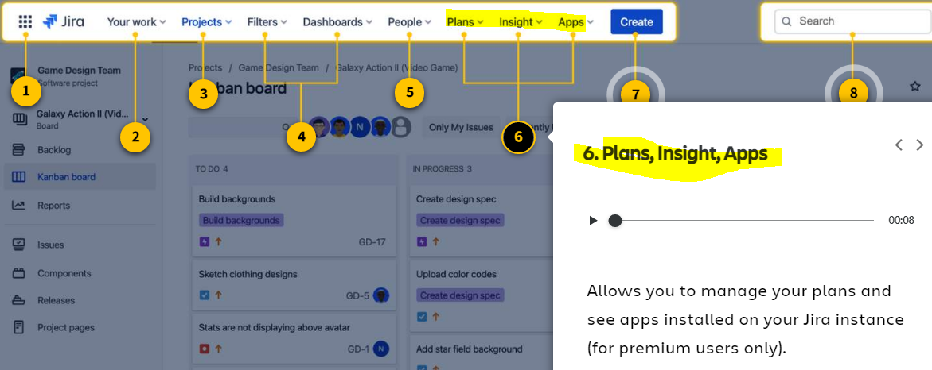

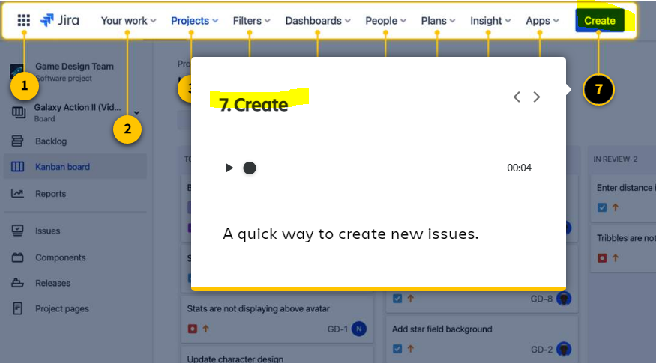

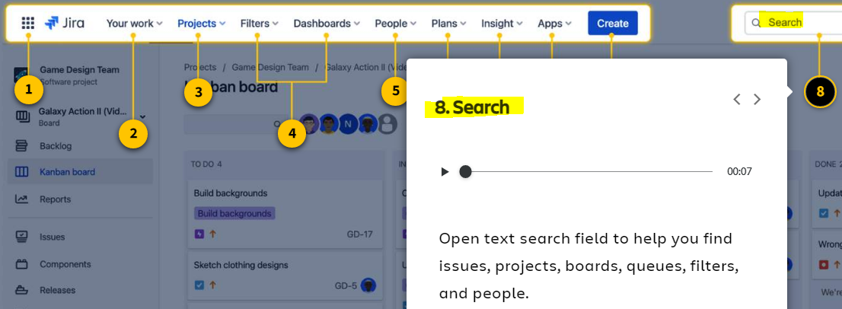

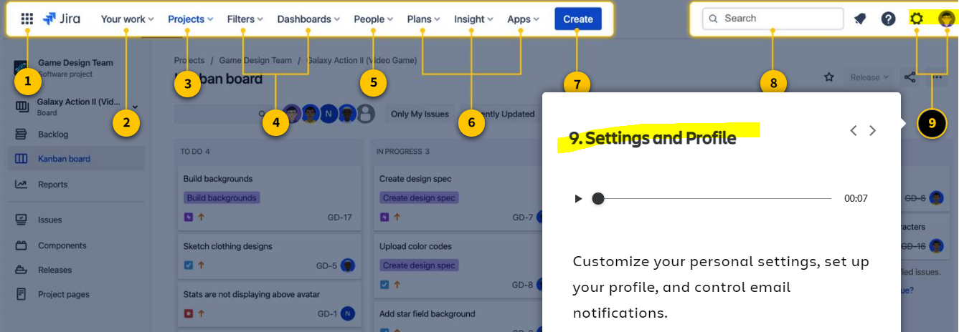

**Prefer to see a list of the main navigation options? Click here.**

–

1. **Product switcher:** Allows you to switch to other Atlassian products your team may be using, like Confluence or Bitbucket.
2. **Your work**: Shows issues, projects, and boards you’ve recently visited. And allows you to view all work assigned to you.
3. **Projects:**Shows a list of all of your projects. And includes a button to create new projects.
4. **Filters and Dashboards:**View any saved or starred filters and dashboards to see your work. You'll learn more about filters and dashboards in future courses.
5. **People:** Shows a list of the people and teams you interact with most.
6. **Plans, Insight, and Apps:** Allows you to manage your plans and see apps installed on your Jira instance (for premium users only).
7. **Create:** A quick way to create new issues.
8. **Search:**Open text search field to help you find issues, projects, boards, queues, filters, and people.
9. **Settings and Profile:** Customize your personal settings, set up your profile, and control email notifications.

**What are starred items? ⭐**

You may notice some items with stars beside them. In Jira, you can **star** your most important projects, boards, and filters so you can easily find them later.

Specifically in the *'Your work'*and *'Projects'*dropdowns, Jira organizes your starred items and shows them first. You can reorder your starred items by going to **Your work > Starred**.

👇 *Here's how to star a board and how to find a starred board.*

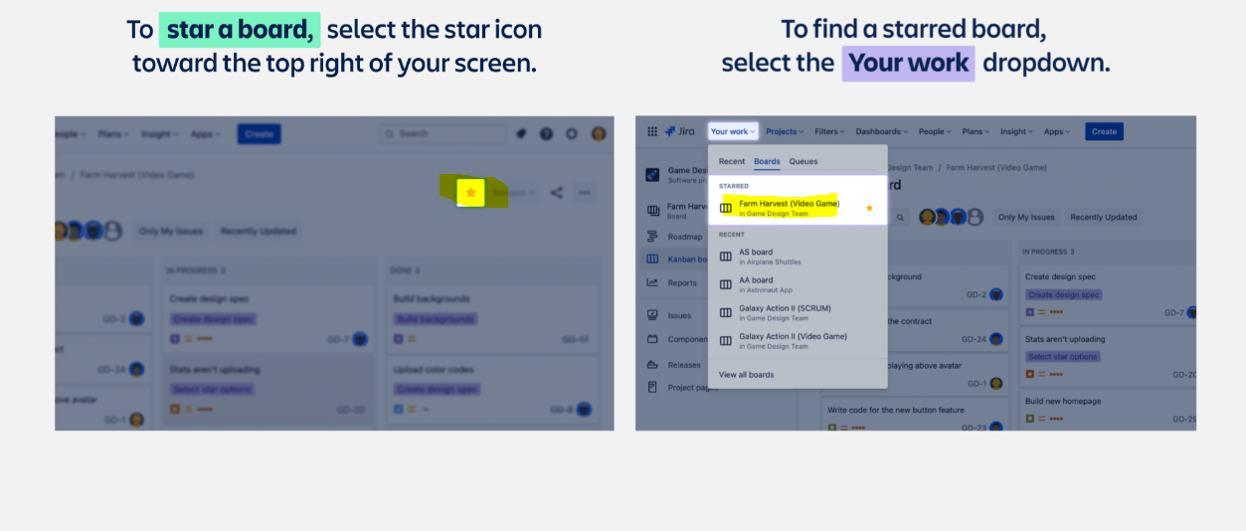

**What's in the project sidebar?**

👇 *Click the number icons to learn about each option in the project sidebar.*

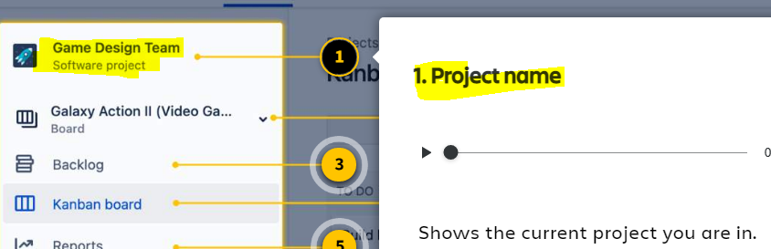

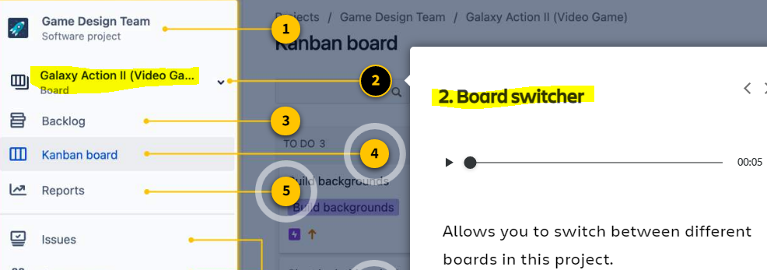

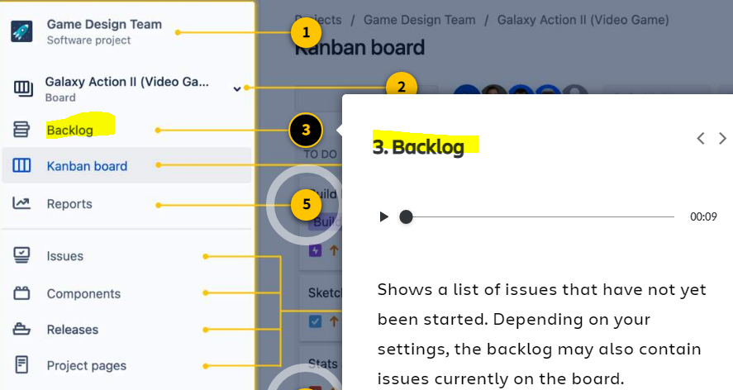

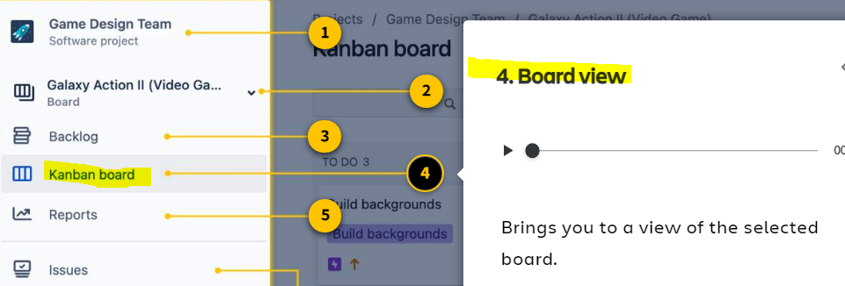

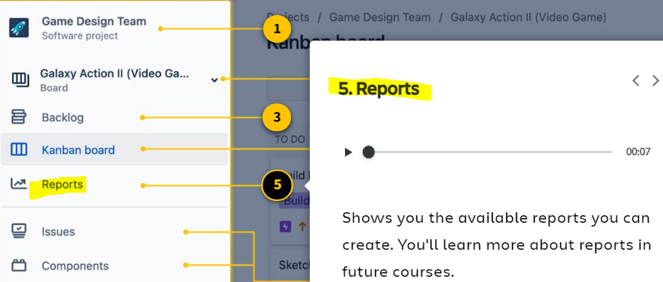

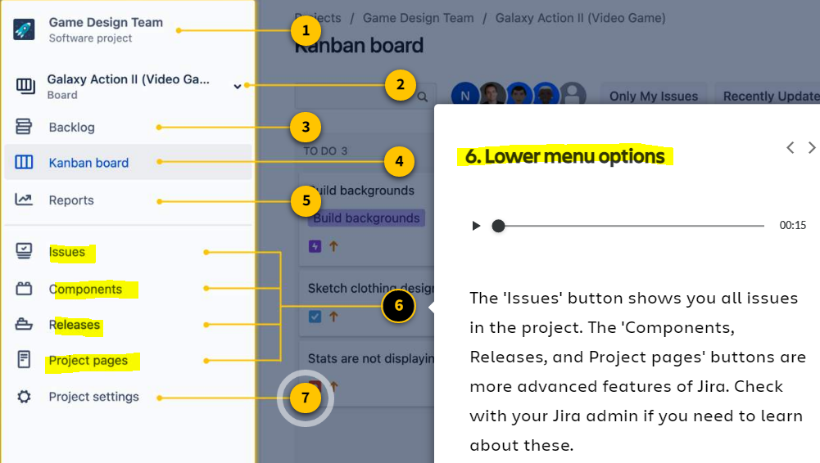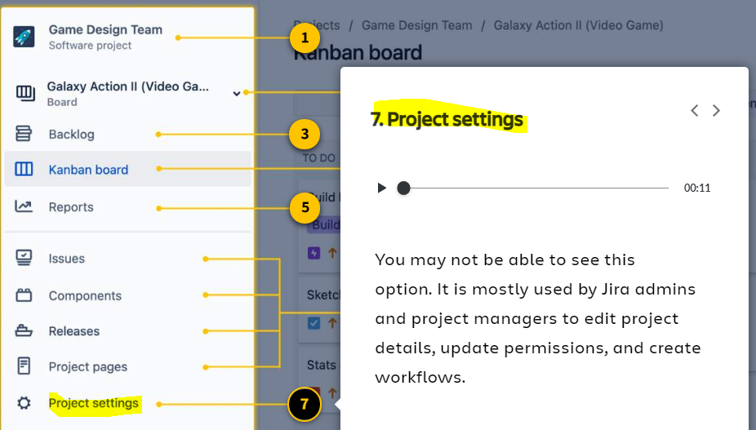

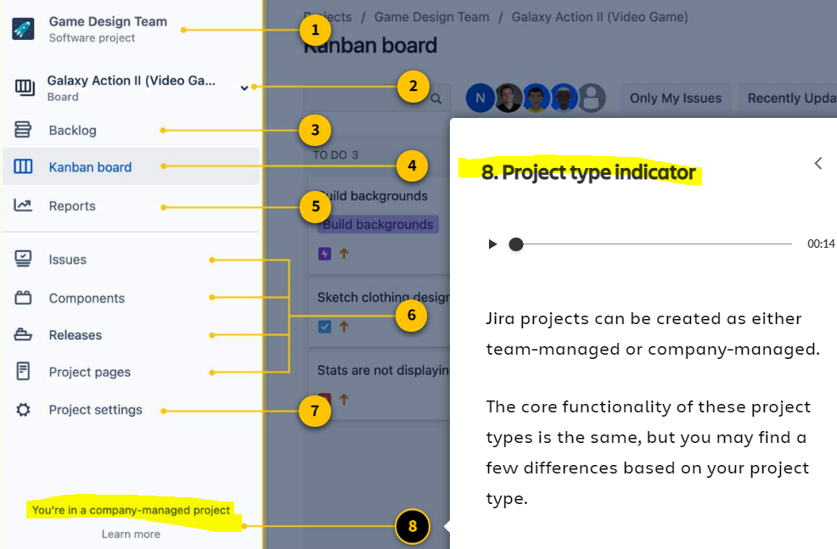

**Prefer to see a list of the project sidebar options? Click here.**

–

1. **Project name:** Shows the current project you are in.
2. **Board switcher**: Select this dropdown to switch between different boards in this project.
3. **Backlog:**Shows a list of issues that have not yet been started. Depending on your settings, the backlog may also contain some issues currently on the board.
4. **Board view:**Brings you to a view of the selected board.
5. **Reports:** Shows you all the available reports you can create. You'll learn more about reports in future courses.
6. **Lower menu options:** The 'Issues' button shows you all issues in the project. The 'Components, Releases, and Project pages' buttons are more advanced features of Jira. Check with your Jira admin if you need to learn about these.
7. **Project settings:** You may not be able to see this option. It is mostly used by Jira admins and project managers to edit project details, update permissions, and create workflows.
8. **Project type indicator:** Jira projects can be created as either team-managed or company-managed. The core functionality of these project types is the same, but you may find a few differences based on your project type.

**Working with Issue**

**What's inside an issue?**When you open an issue, you'll see the issue detail view.

In this view, you'll see many **issue fields**. Issue fields include the editable items such as the due date, assignee, comments from teammates, priority levels, and links to related media.

**How do you open an issue to see its details?**

1. Start from the board view. Navigate to the project sidebar and select '**Kanban Board'**or**'Board.'**
2. Find an issue card and **click to open it.**

The example screens below highlight the most common issue fields. Your specific fields will be customized based on your team. Check with your project manager or Jira admin to know which specific issue fields your team will be using.

👇*Click the number icons to learn about the most common issue fields.*

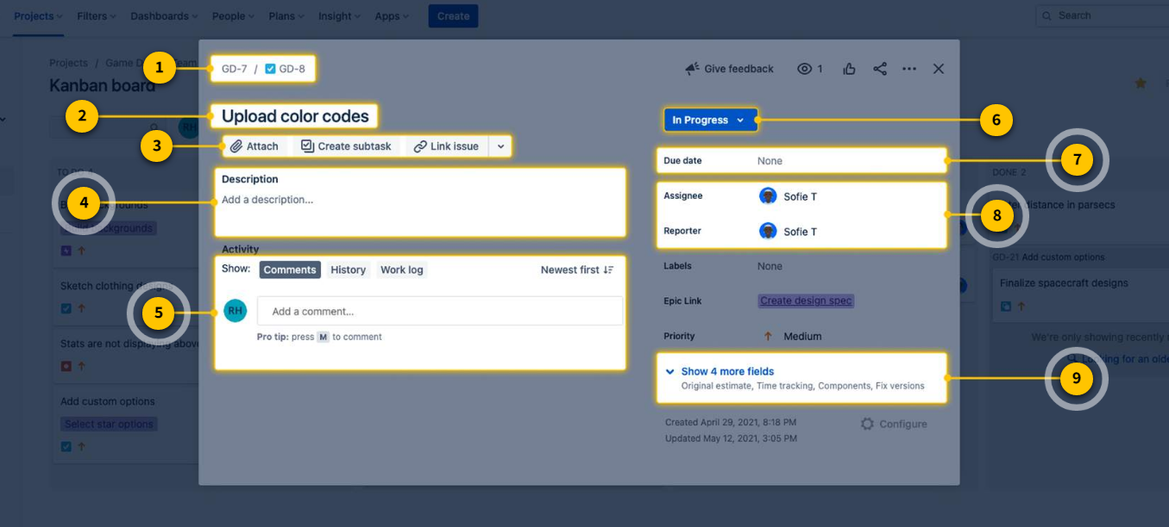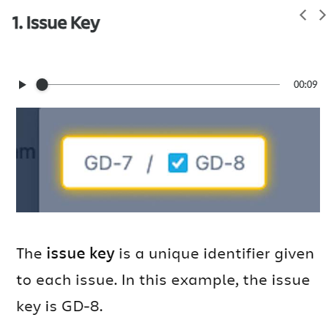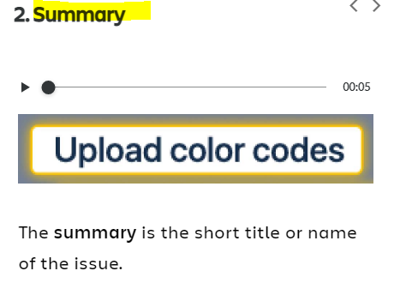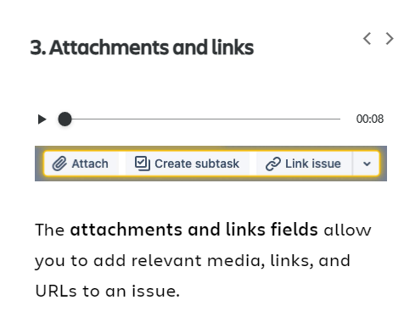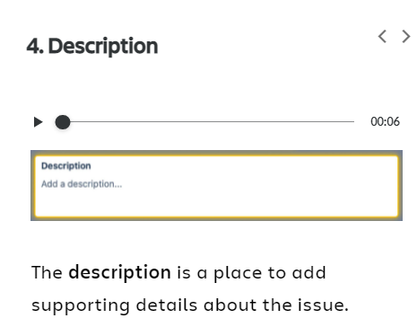

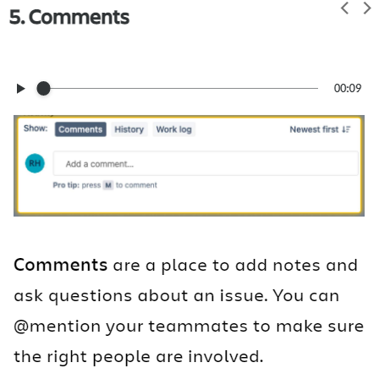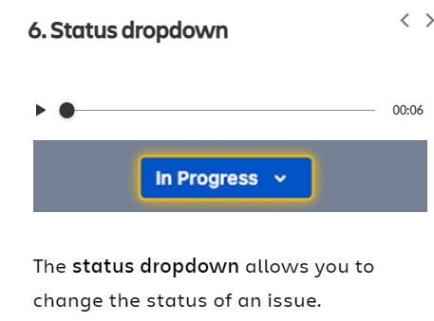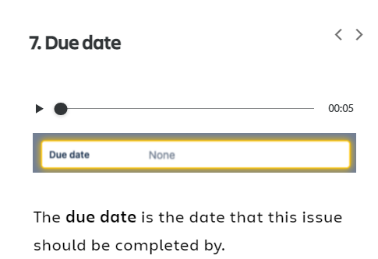

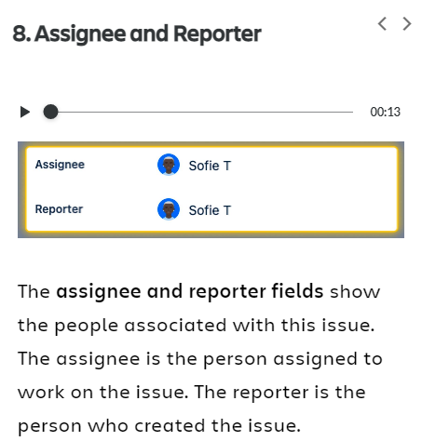

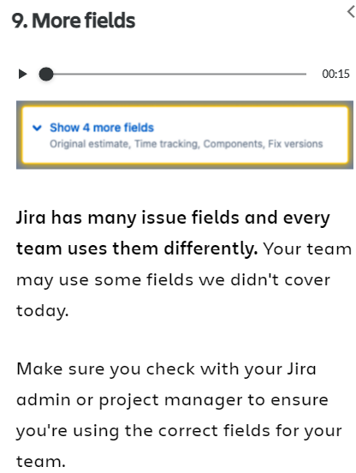

1.The **issue key**is a unique identifier given to each issue. Issue keys contain the project key and a sequential number. In the example below, the issue key is GD-8.

**Why is this field important?**The issue key helps you find issues or refer to work with your teammates.

To the left of the issue key is a small icon. This icon indicates the issue type. You'll learn more about issue types below.

2. The **summary** is the short title or name of the issue.

**Why is this field important?** The summary helps you quickly recognize the issue. It appears on the issue card as the issue name.

3. The **attachments and links fields** allow you to add relevant media, links, and URLs to each issue.

**Why are these fields important?**They help enrich an issue by connecting the issue to related media.

4. The **description** is a place to add supporting details about the issue.

**Why is this field important?** The description helps you better explain and understand an issue.

5. **Comments** are a place to add notes and ask questions about an issue. You can @mention teammates to notify them of important updates.

**Why is this field important?** You'll use comments often. They are a great way to collaborate with your team and keep everyone in the loop.

6. The **status dropdown** allows you to change the status of an issue.

**Why is this field important?** You'll use the status dropdown often. Whenever work progress changes, use this dropdown to update the issue's status. You can also change an issue's status in the board view, by dragging and dropping the issue into its respective column.

7. The **due date** is the date this issue should be complete.

**Why is this field important?** Paying attention to issue due dates will help you prioritize work and plan for upcoming weeks.

8. The **assignee and reporter fields** show the people associated with the issue. The assignee is the person *assigned*to work on the issue. The reporter is the person who created the issue.

**Why are these fields important?**If you have a question about an issue, the assignee and reporter fields tell you which teammate to contact.

9. **Jira has many issue fields and every team uses them differently.** Your team may use some fields we didn't cover today. Check with your Jira admin or project manager to ensure you're using the correct fields for your team.

**Not all issues are created equal**

**There are different types of issues based on their size and category of work**

Some issues are large. Others are small. Some are about starting new work. Others are about fixing old problems.

With a wide variety of work, teams need different ways to categorize their different issues. The **issue type** tells you the category and size of the work to get done.

**What are the default issue types?**

In Jira Software, the default issue types are **epic, task, story, bug,** and **subtask.**These issue types are organized into a hierarchy based on the size and category of work.

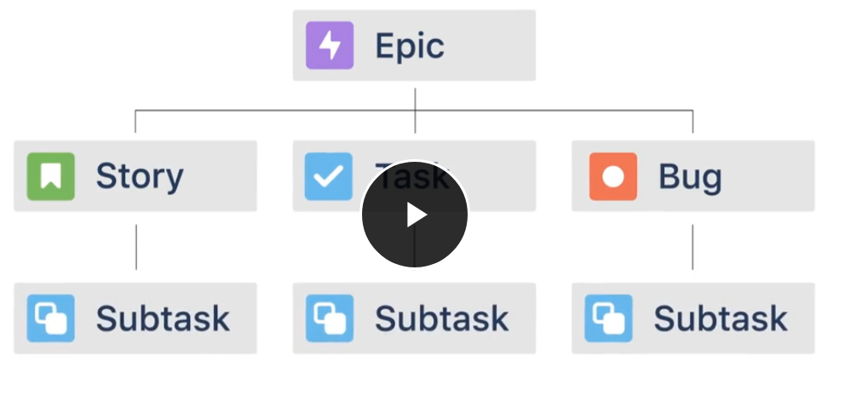

**Epic**

An **epic** is a large initiative. Known as "parent" issues, epics contain smaller issues within them. They often represent large bodies of work that can break down into smaller tasks. It will be up to you and your team to decide what's a large initiative and what's not.

**Task**

A **task** is the most common issue type. They contain a more detailed description of a work item. Tasks can exist within a larger epic or exist all on their own.

**Story**

A **story** is a feature or requirement from the user's perspective. Stories are commonly used by software development teams. They define work items in non-technical language. For example, *"As a user, I need a back button on this screen."*Stories are at the same hierarchical level as tasks, and some teams use the two issue types interchangeably.

**Bug**

A **bug** describes a problem or error, mostly used in software development teams. They can exist within a larger epic or exist all on their own.

**Subtask**

A **subtask** is a further defined issue, used to break down tasks, stories, or bugs into smaller work items. Subtasks must have a parent issue type. They cannot exist on their own.

**How are issue types used? Here's an example.**

**🚀 Imagine a game design team building a space-inspired video game*.*They use the default issue types — epics, tasks, stories, bugs, and subtasks — to organize their work.**

👇 *Click through the tabs to see how the game design team uses issue types.*

**How does the game design team use epics?**

One large initiative for this team is to *'Develop and launch all character profiles.'*

This is a large body of work that will have smaller work items within it. In the image below, you'll see that *'Develop and launch all character profiles'*is an issue at the epic level. Underneath the epic, there are multiple tasks to complete.

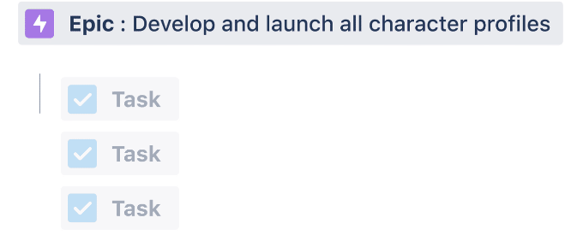

**How does the game design team use tasks/stories?**

Within the epic, *'Develop and launch all character profiles,'*there are multiple tasks that need to get done.

Each task is actionable and well-defined. Day-to-day, the team will mostly be working from these task-level issues. Notice how each task-level issue is a part of the larger epic.

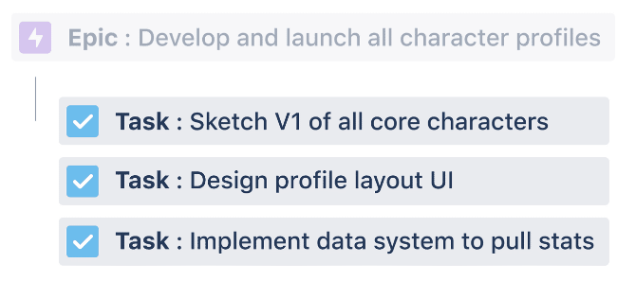

**How does the game design team use bugs?**

When the game was in review, an error was found on the profile layout UI. The save button wasn't working correctly. The team added a bug issue, *"Fix save button error on profile UI"* to this epic. This will help the team resolve the bug right away.

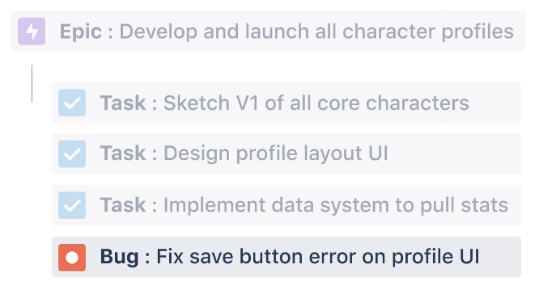

**How does the game design team use subtasks?**

Sometimes tasks and stories need to be broken down even further.

Within the task, *'Sketch V1 of all core characters,'* there are some smaller steps that need to happen. The game design team has created subtasks for each of these steps.

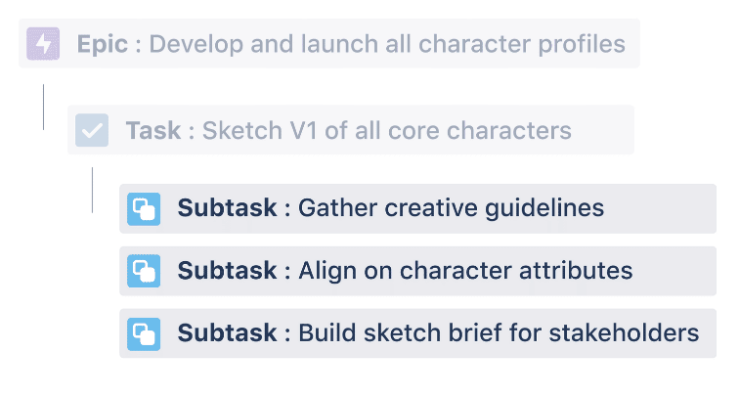

# How to update and create issues

**You've got an issue open. Which fields should you update?**

This depends on your team's preferences and how your work is set up. However, there are a few fields you'll likely update often. **The most common fields you'll update are the status and comment fields.**

**Update the status**

By now, you know a lot about statuses. Whenever your work progress has changed, you'll update the issue's status.  For example, if you're ready to start work on an issue, you would change the status from **To Do** to **In Progress.**

**✅ How do you update the status?**There are two ways. On the board view, you can drag and drop the issue into a different column. Or, in the issue detail view, you can click the status dropdown and select the new status.

**Add comments**

Comments should be your go-to issue field. They provide the best way to ask questions and share updates. You can also @mention teammates to bring attention to important info.

**✅ When should you use comments?** Use comments when you need to communicate progress, ask a question, find resources, or receive feedback. You can also add reactions to comments with popular emojis like 👍 or 🔥.

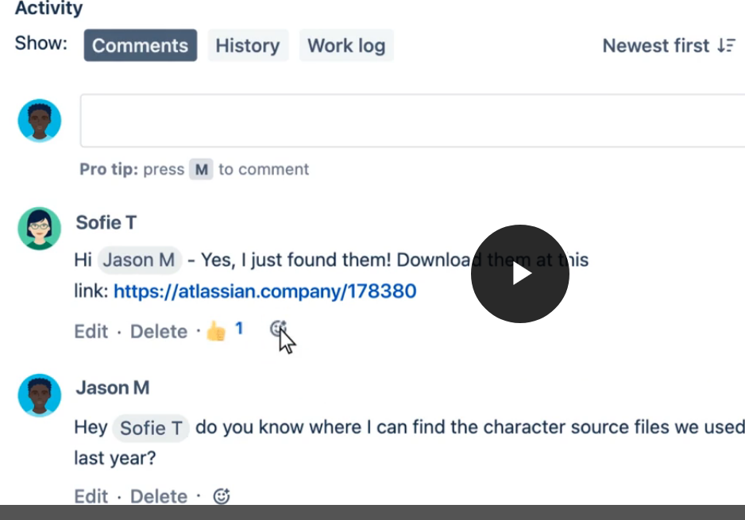**How often should you update issues?**

Try to make Jira a daily habit and update your issues every day. When work progress changes or you need to ask a question, default to updating the issue in Jira. This practice will help everyone on your team stay in the loop.

**📩For any issues you own or have starred, you'll receive email notifications.**When a teammate @mentions you in a comment, Jira sends you an email. That email has a link that takes you directly to the issue. Email notifications are a great way to remind yourself to update your issues.

👇 *Here's how a Jira email notification might look.*

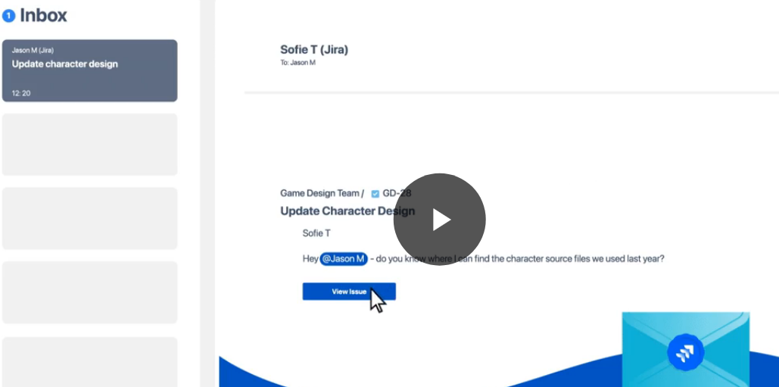**How to create new issues**

Some teams prefer that only project managers or scrum masters create new issues. Other teams allow any Jira user to create new issues. Before you start creating your own issues, check with your project manager.

**The simplest way to create new issues is to click the '*Create'* button in the main navigation bar.**

👇*In the main navigation bar, click 'Create' to begin creating a new issue.*

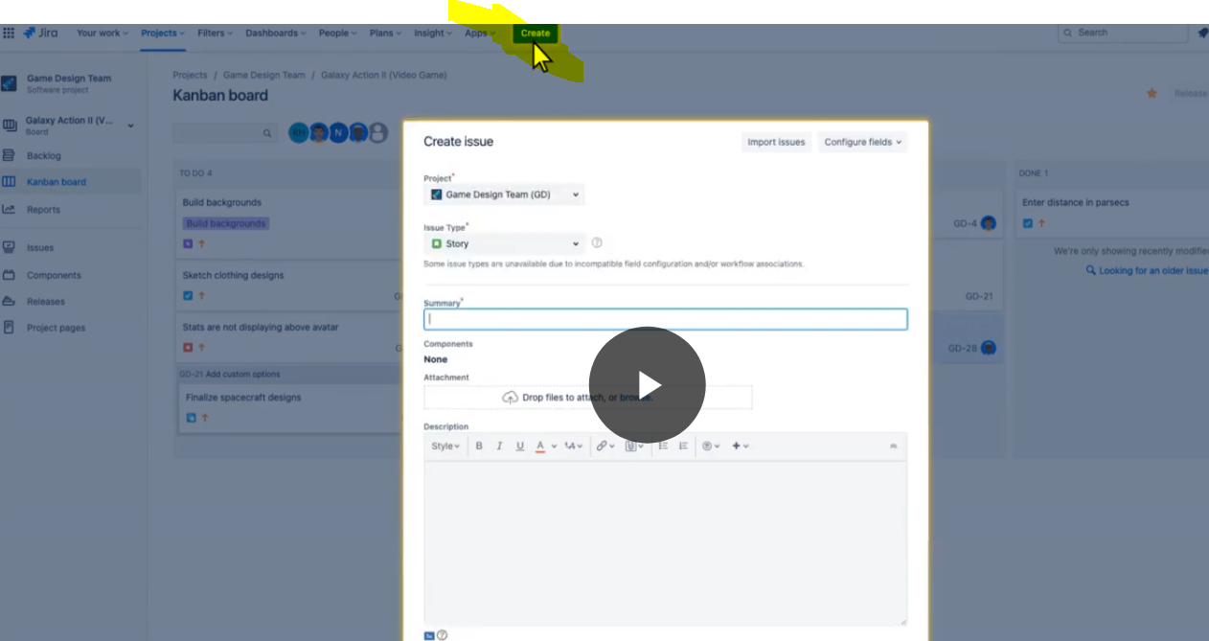**Which fields should you fill out?**

Start with the required information: **project**, **issue type**, and **summary**. The description field is optional, but filling it out helps give your issue more context.

👇 *Click the number icons to learn how to fill out each item on the form.*

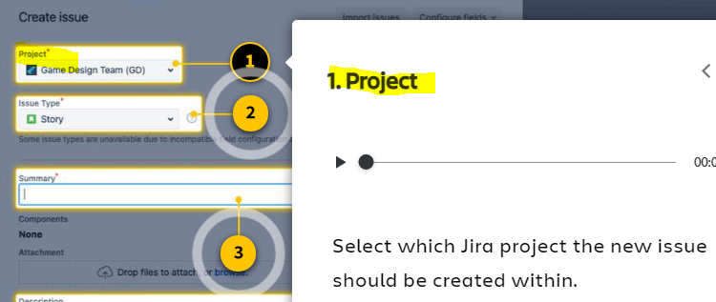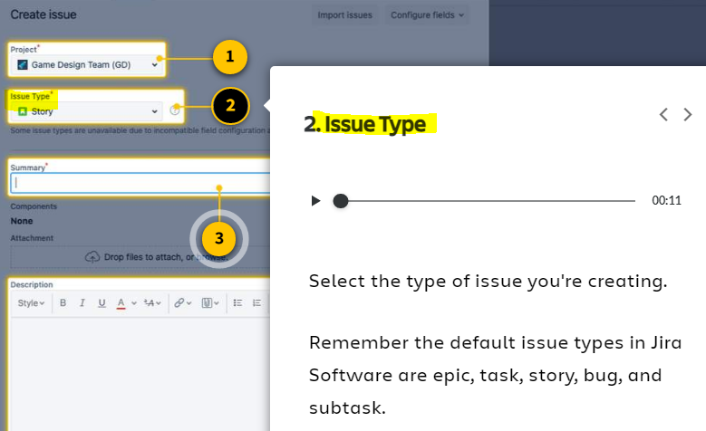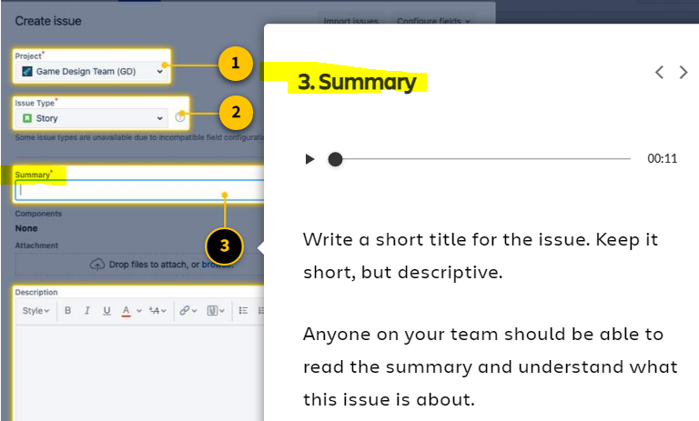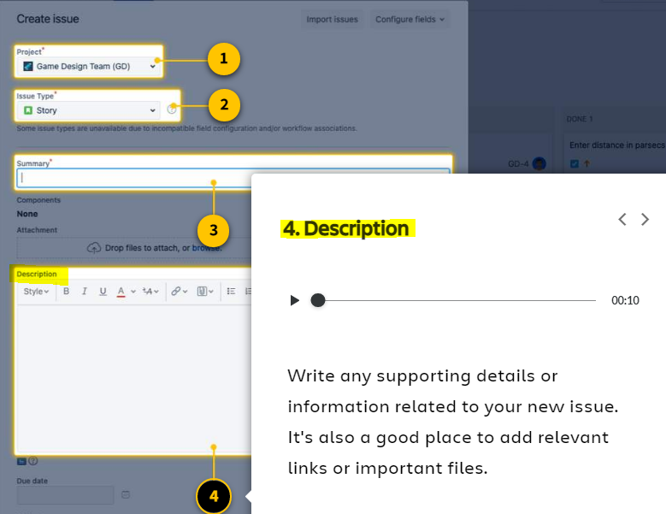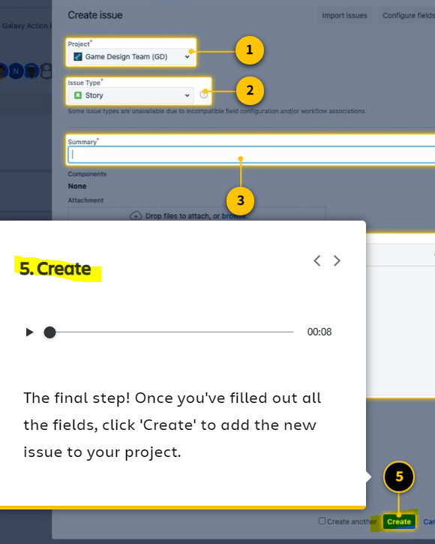

**You created an issue! Now where did it go?**

**The best place to look for your new issue is the  backlog**. The backlog shows a list of issues that haven't been started yet. You'll learn more about the backlog in the next lesson.

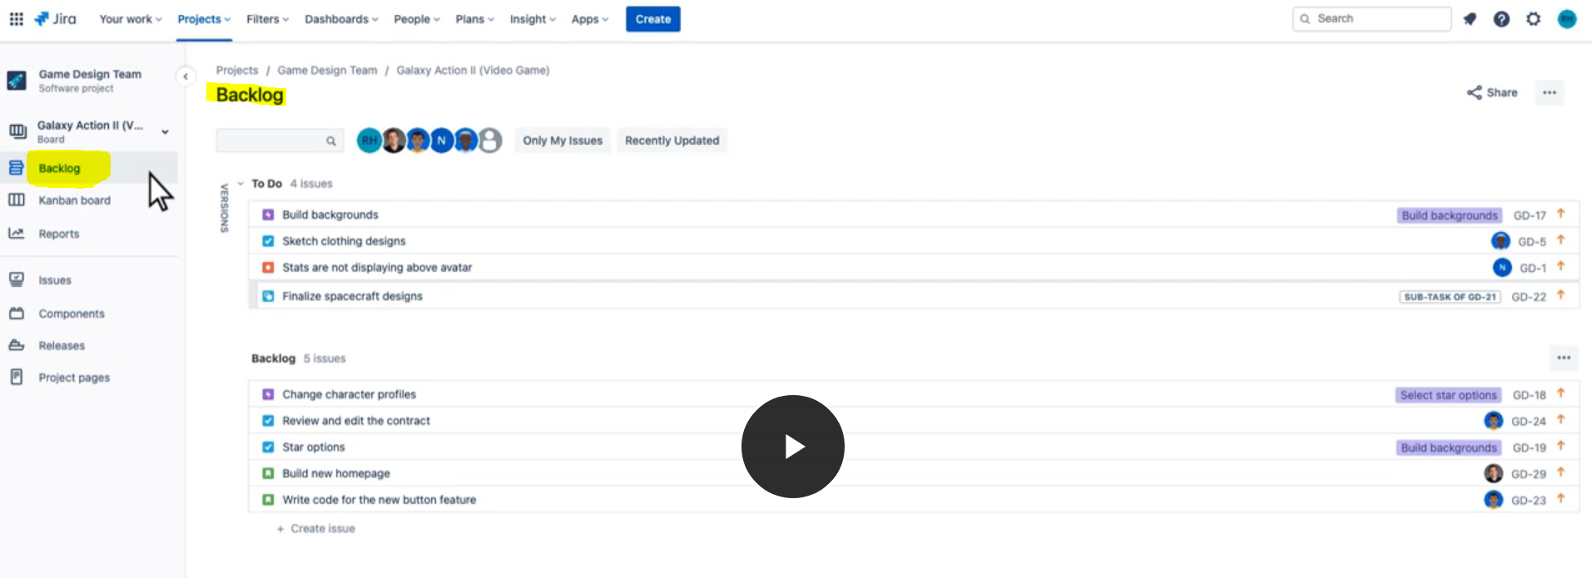

# Views and search in Jira

**Introducing the backlog and roadmap**

To view your daily work, boardswill probably be your go-to view. But the **backlog**  and **roadmap**  are other important views that give you a different perspective on your work.

**The backlog shows issues that have yet to be started. The roadmap shows all issues in a linear timeline.**

👇*Here's what they look like.*

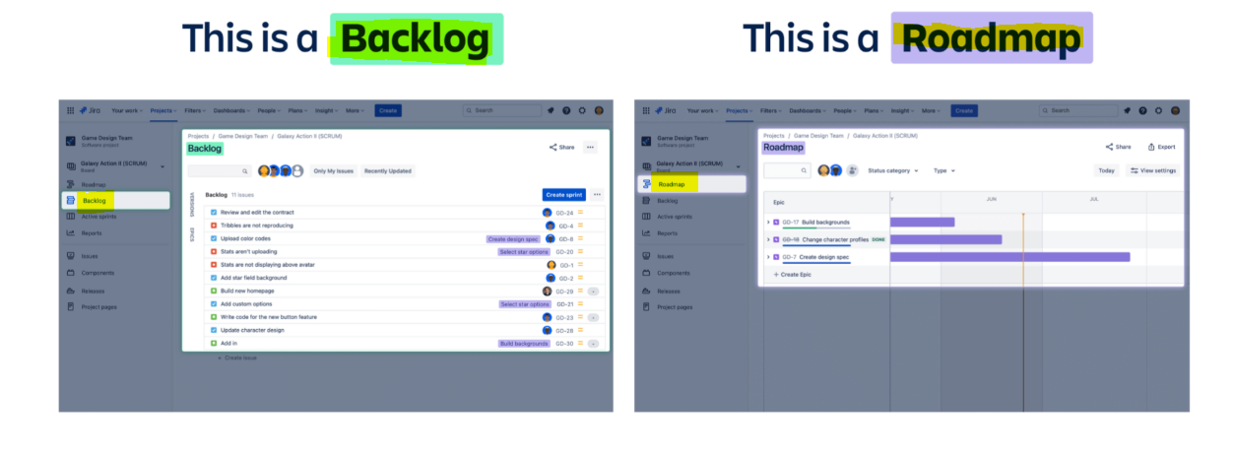**The backlog shows issues not yet started**

Not every issue is worked on right away. Your team probably plans issues for the future. These issues will sit in the backlog until they are ready to start.

**How do you access the backlog?**On your project sidebar, select *'Backlog.'*Some teams also customize their boards to show the*'Backlog'* in a column.

👇*To see your backlog issues, navigate to your left project sidebar and select 'Backlog.'*

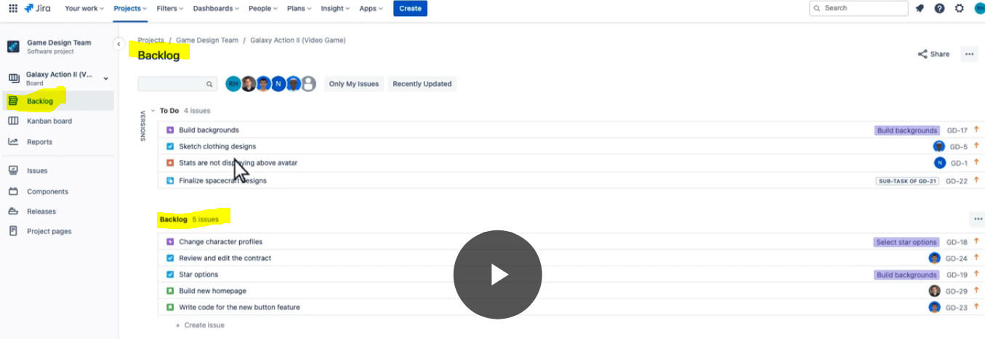

**The roadmap shows the big picture in a timeline view**

Sometimes it's helpful to see how issues start, end, and overlap. The roadmap view shows issues in a linear timeline. This helps teams map dependencies and plan work accordingly.

**How do you access the roadmap view?**On the project sidebar, select *'Roadmap.'* If you don't see this option, navigate to your main navigation bar and select *'Plans.'*In the dropdown, you may see a *'Roadmap'*option.

👇*To get to the roadmap view, navigate to your left project sidebar and select 'Roadmap.'*

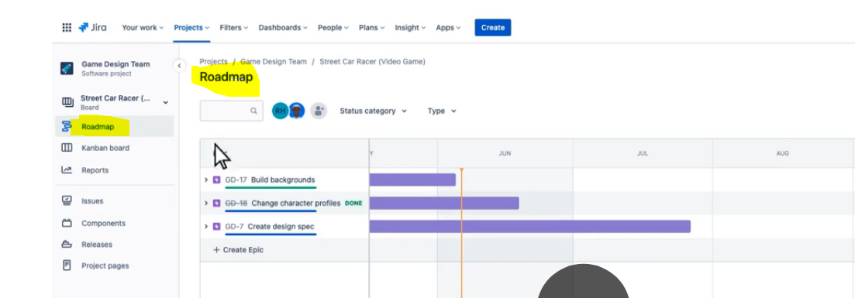

**Search for issues you can't find**

There are two simple ways to search for issues: the **search bar** and **basic search**.

👇*Here's what they look like*

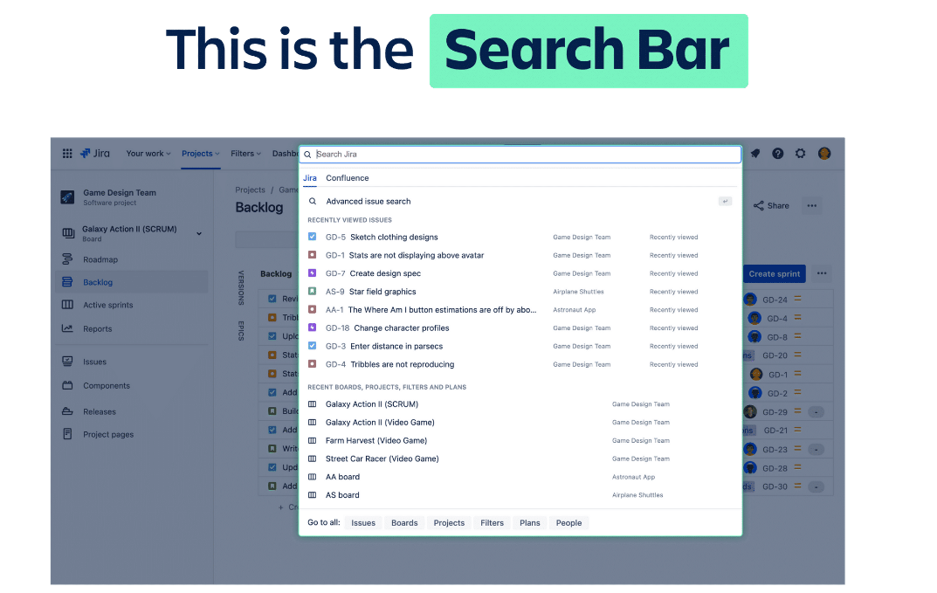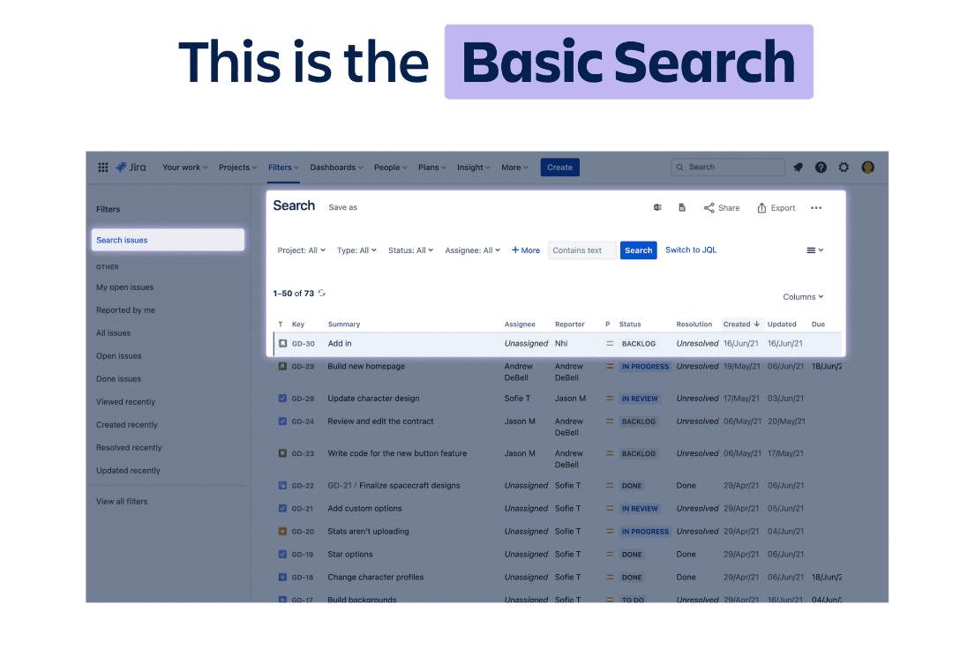**Use the search bar to find issues quickly**

The search bar is located near the top right of the main navigation bar. Here are some tips for using it:

**🔍 Click in the search box to see recent work.**Before typing a single word, the search bar populates a list of recent issues, boards, projects, and filters.

**🔍 Let Jira guess your search.**As you type, Jira tries to guess what you're searching for. Watch your screen for instant search results, even before you’ve finished typing.

**🔍 Can't remember the issue name? Search for any related word.**Jira will scan other fields like descriptions and comments to find your issue.

**Use basic search for more specific criteria**

Try basic search if the search bar didn't work for you. In basic search, you can filter and sort issues by specific criteria.

👇 *Learn how to use basic search by clicking through the tabs.*

Click on the search bar. Navigate to the bottom and choose **Go to all > Issues**

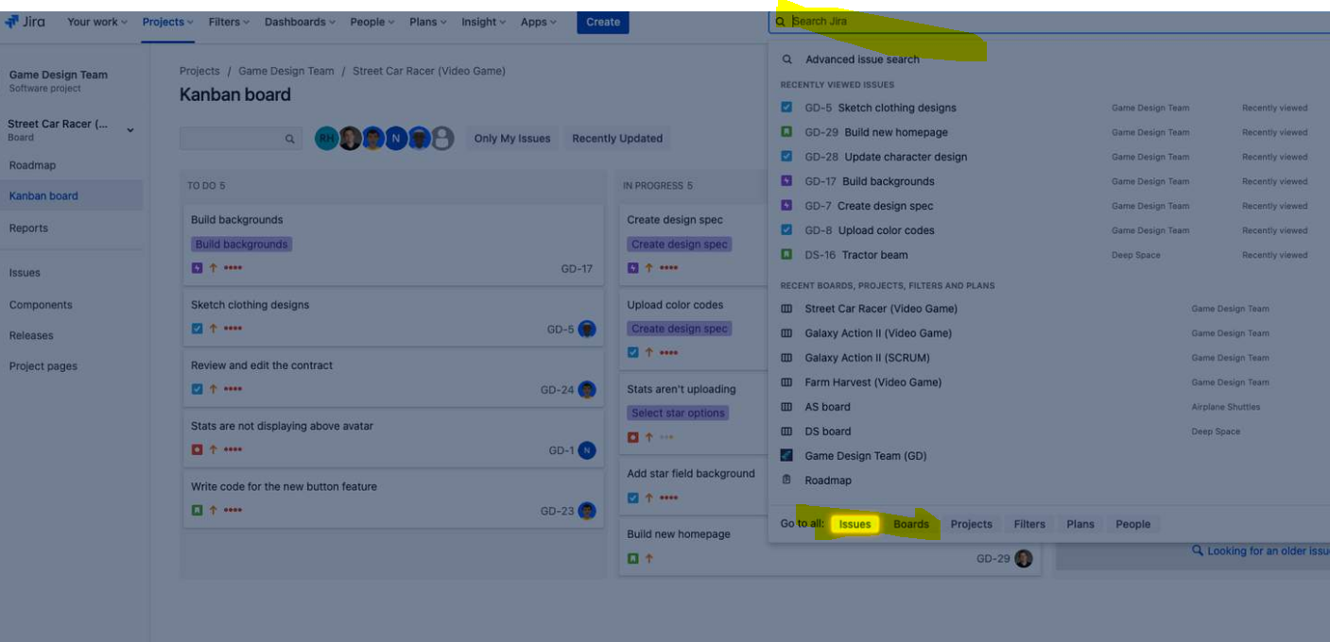

**Use the dropdown menus to set your criteria.** You can search by criteria like project, status, type, assignee, or other combinations.

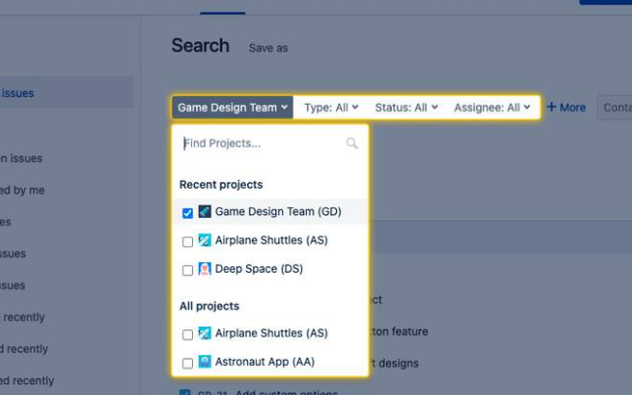

**Click +More to add filters that narrow your search even further.**Select your desired filters and criteria.

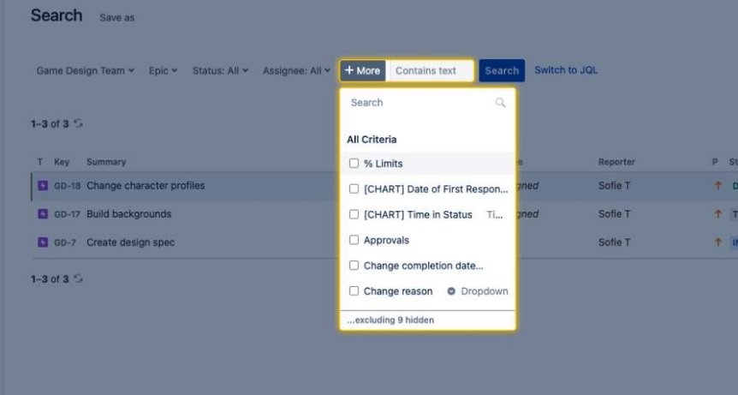

**When you've got all your criteria and filters set, click 'Search' and see the results.**

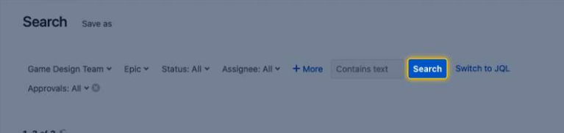

***Jira best practices***

**Welcome to *Jira best practices*.**If you landed here, you're ready to upgrade your Jira skills.

Today, you'll learn how to get the most out of Jira. You'll discover how to incorporate Jira into your daily routine, along with custom settings, features, and views to improve your Jira experience. After completing this course, you'll have tons of valuable tips and strategies to share with your team.

**Ready to improve your Jira skills? Let's get going. 👍**

# Build your daily Jira habit

**What's the biggest difference between pro and novice Jira users?**

You guessed it: how often they use the tool. Novice users aren't consistent. They rarely check Jira. They don't keep issues up-to-date. This inconsistency creates confusion and frustration among teammates.

**Pro users make Jira part of their daily routine.**They have a habit of checking and updating Jira continuously each day. These pros realize using Jira consistently helps them be better at their jobs. More productive. More organized. More collaborative. A higher-performing teammate, overall.

**You too can build a daily Jira habit and become a productivity pro.**Add Jira to your daily routine, and you'll quickly see the benefits.

**Why make Jira a daily habit?**

Building Jira into your routine will benefit you in your job and career. Here's how:

**✅ It'll keep you organized.**Updating Jira daily means all your work is in one place. Each day you have a single location to view your current and upcoming work. You can see which issues are top priorities to get done first.

**✅** **It'll help you track your performance.** Keeping your Jira issues up-to-date means you have data on your work performance. This data can be a powerful tool to use in career conversations with your manager.

**✅ It'll keep you in the loop on your team's work.** Team transparency is a luxury. Using Jira every day means you and your teammates know what's happening across your projects. It's a great way to stay connected and up to speed.

**How to build your daily Jira habit**

**1. Keep Jira open, always**

Make Jira easy for you to access. No need to log in and out. Stay logged in and keep the tab open in your browser, always.

**Are your Jira browser tabs challenging to find? Try this:**Create a color-coded tab group called *"My Jira Boards."* If you have many tabs open, the color code and label help you find your Jira boards quickly. Another option is to keep an entire browser window open dedicated only to your Jira projects.

👇*In Google Chrome, you can create a color-coded tab group for your Jira boards and projects.*

**Right Click on the opened tab ->select add tab to new group ->Choose color n name the group …for all other tabs if you want to add in same group the just drag that tab to this group.**

**Note:-when you close the chrome window this group will be deleted so what you can do is like go to chrome ->click on … ->choose setting->go to default browser->under on-startup panel select continue where you left off**

By selecting continue where you left off if your previous session was having any tab groups opened then it will be opened next time when you open chrome window otherwise no tab group will be opened.

**2. Start your workday with Jira**

For many humans, the most consistent routines are at the start of the workday. Many of us check email. Or browse our calendars. This is a perfect opportunity to bring Jira into the mix.

**Try adding Jira to the current stack of your workday activities.**After browsing your calendar, open Jira. In less than 60-seconds, you can see all your work tasks to help prioritize your day.

 After a few weeks of checking Jira at the start of the workday, you'll be more focused and organized than ever before.

**3. Commit to a month-long Jira streak**

A habit streak is when you complete a task continuously over a long period. It's a powerful tactic to make any new behavior stick. Habit streaks help you focus on repeating a behavior day in and day out, quickly making it part of your permanent routine.

**Try challenging yourself to use Jira every day for an entire month.**Each day it'll take just a few minutes of your time. After one month, you'll have built a healthy habit that's part of your routine.

Keep yourself accountable by adding events to your calendar. For example, try setting 15-min calendar events that repeat daily to remind you to "Check Jira and update issues."

You can track your Jira habit streak with a habit-tracking smartphone app. Or in your calendar.

**4. Be the Jira champion on your team**

Remember, Jira works best if your *entire team* uses it every day. With your new Jira skills, you can be your team's productivity advocate and get everyone on board.

**How does this help you build your habit?**When you encourage others to use Jira, your own habit is positively reinforced. Your efforts will quickly grow into consistent Jira habits for everyone on your team.

**Try using Jira to document all team-related questions and activities.**Start small by keeping your issues up-to-date. If a teammate asks you for an asset related to an issue, add the asset in a comment in the Jira issue. Then @mention your teammate to let them know. Be consistent in this practice for every teammate's request. Over time, your teammates will get the picture and default to managing their work in Jira.

**5. Optimize Jira for you**

You'll use Jira more often if it's set up exactly how you'd like. As a flexible tool, Jira has a variety of features for you to customize. You can adjust personal settings, set notification frequency, create custom work views, connect Jira to other tools, and much more.

Continue in this course to learn how to optimize Jira for you.

**You probably spend a lot of time with issues.**Creating. Updating. Managing**.**

While there are no set rules around issues, there are a few simple strategies that can make your life easier. We've compiled a list of issue best practices that most Jira users can use.

The following section contains a list of issue best practices for both **creating issues** and **managing issues.**

**1. Write short and clear summaries**

The **summary** is the title of an issue. Summaries are required for every new issue you create. The best practice is to keep each summary between 4-7 words. Write them in crisp and precise language so anyone on your team can understand at a glance. Here are a few suggested writing formats to try:

**🟡 Tasks -** Write task summaries like this: "<**ACTION**> <**ACTIVITY/THING**>." (e.g., "Build new homepage")

**🟡 Stories -** Write story summaries like this: "As a <**PERSONA**>, I want <**THING**>." (e.g., "As a user, I want a back button")

**🟡 Bugs -**Write bug summaries like this: "<**FEATURE**> should do <**X**>, but does <**Y**>." (e.g., "Menu button should show menu, but errors out")

**2. Create multiple issues at a time with the roadmap or backlog**

You may need to create more than one issue at a time. When planning new initiatives from start to finish, you can create a sequence of new issues from a single view. Both the roadmap and backlog provide this option.

**➡️ To create multiple issues from the roadmap,**select the button 'Create issue.' Type in a summary. Save your changes by selecting 'Review changes' at the top right of your screen.

**➡️ To create multiple issues from the backlog,** scroll to the bottom of the backlog and select 'Create issue.' Type in a summary.

**3. Flag important issues**

You can add a **flag** to any issue to indicate its importance. When a flag is added, a small flag icon will be visible on the issue card and the issue card will turn yellow.

It's a great way to bring awareness to any issue that requires escalation. You may need to flag an issue that is in danger of missing its delivery date. Or flag an issue that's blocked by another task or problem.

🚩To add a flag to an issue:

* Open an issue
* Select the ellipses ***•••***and select ***Add flag***

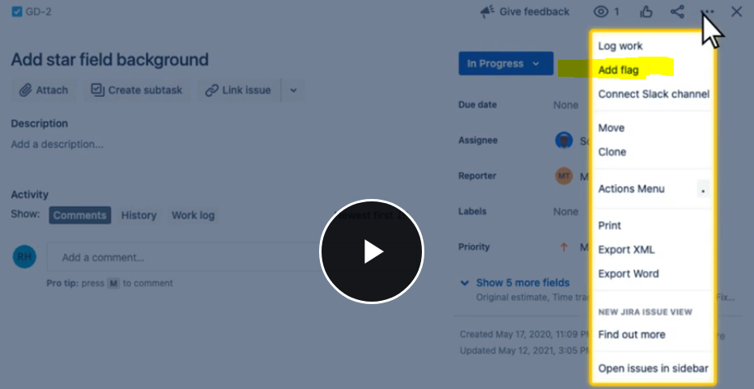

**4. Use email notifications to stay connected**

Email notifications help you stay on top of your issues. By default, Jira sends you a lot of emails. But they're all important!

📥 Anytime an issue changes status or you are @mentioned in a comment, you'll get an email. While it may feel like overload, these emails keep you well-connected to your issues and your team.

Every email from Jira includes a direct link to the issue. While you can change your email notification settings in Jira (as you'll learn soon), we recommend that you keep your notifications turned on. It'll help you be efficient and in the know on all work related to you.

**5. Use comments for every communication**

Comments should be your go-to feature in Jira. They are the ultimate tool to collaborate with your team and keep work organized.

Use comments to document any update, question, or request, even if it feels trivial. This way, your team will see the entire history of an issue's progress through the workflow. This can help you more accurately plan your future work.

The best practice is to use comments to communicate progress, ask questions, find resources, ask for opinions, get ideas, request feedback, and @mention teammates. When used consistently, comments create a source of truth for your work. They gather updates in one place and allow anyone on your team to get up to speed quickly.

**💥 If there's one best practice to take away from this lesson, use the Jira comments. For every communication!**

# Adjust your personal settings

Jira is a flexible tool, allowing for a variety of customizations. While your Jira admin or team leader will set up many customizations, there are a few important settings you can control.

To access your personal settings:

1. Select your **profile picture icon** at the top right
2. Select **'Personal settings'**
3. Update your preferences and select '**Save changes'**

👇 *Click the numbers to learn about each personal setting.*

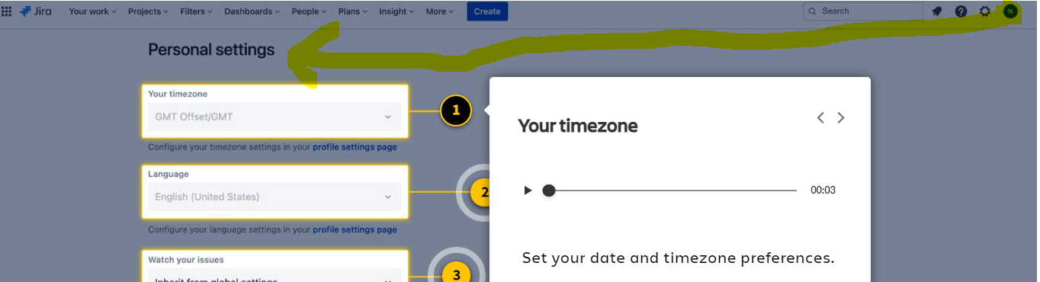

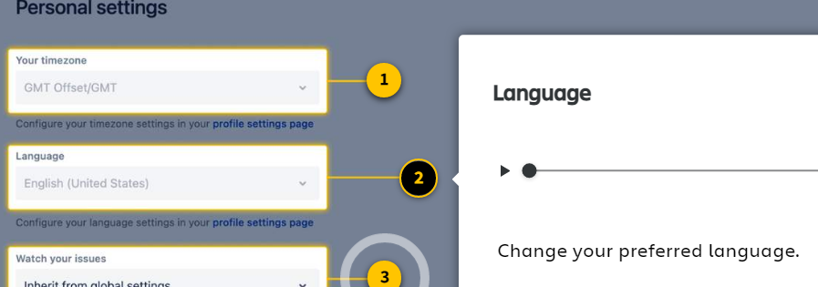

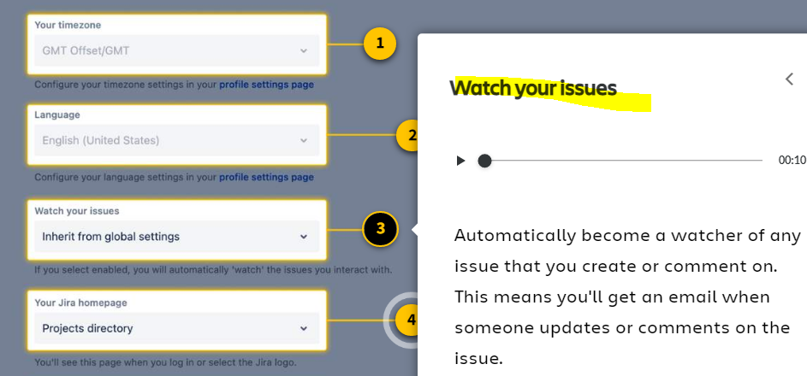

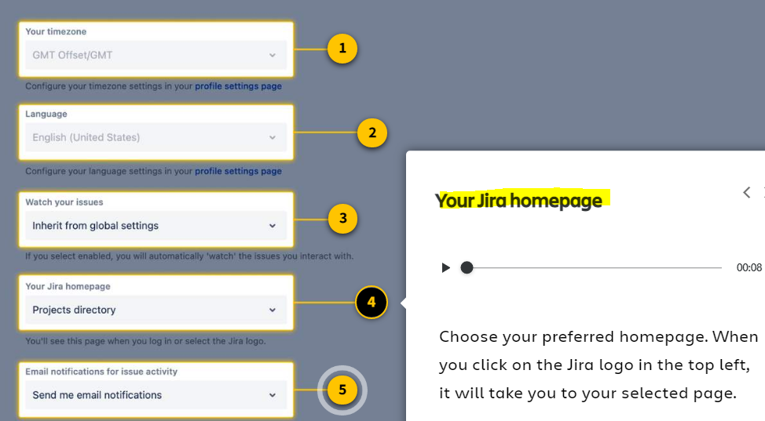

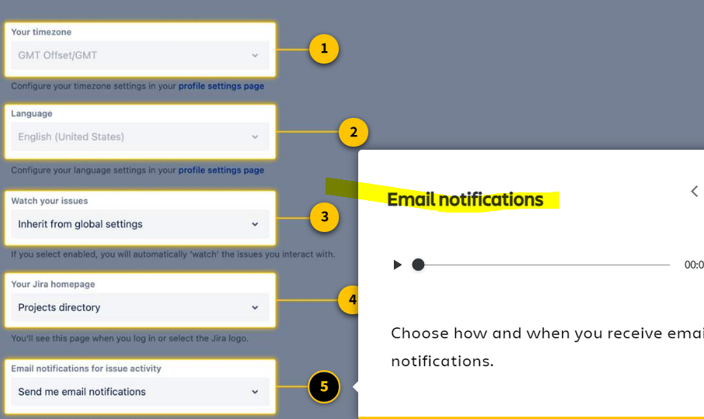

**1. Your timezone**  
Set your date and timezone preferences.

**2. Language**  
Change your preferred language.

**3. Watch your issues**  
Automatically become a watcher of any issue that you create or comment on. This means you'll get an email when someone updates or comments on the issue.

**4. Your Jira homepage**  
Choose your preferred homepage. When you click on the Jira logo in the top left, it will take you to your selected page.

**5. Email notification preferences**  
Choose how and when you receive email notifications.

**Tips to optimize your personal settings**

**1. Stay in the loop by enabling 'Watch your issues'**

**👀 With this setting, you automatically become a watcher of any issue you interact with.** This means you will receive notifications any time there is an update to the issue.

**Why is this helpful?** It helps you keep track of your work, always. In Jira, you'll often work on issues where someone else is the assignee. You're still a contributor, though. You still need to know about updates and changes to the issue.

By enabling 'Watch your issues,' you'll automatically stay in the loop with email notifications. If the emails get overwhelming, remember you can always un-watch an issue to stop receiving the messages. To un-watch an issue, click the eye icon within the issue details.

👇 Here's how to enable 'Watch your issues.'

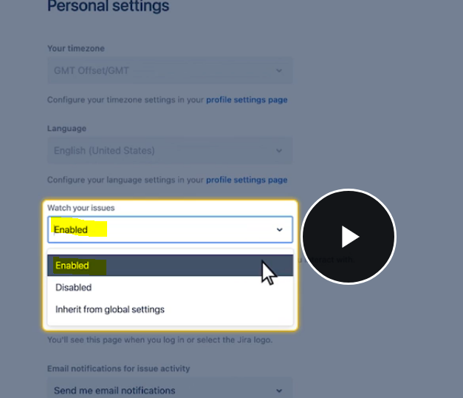

How to disable the watch if let say you are not the responsible person for that issue then you might want to stop getting the mails from that issue for that we need to disable the watch that we can do by clicking on the eye button inside an issue like below :

Below img shows eye option in issue n count to stop getting the mails from this issue we can click on the eye button n then select stop watching this will disable this feature of getting mails..

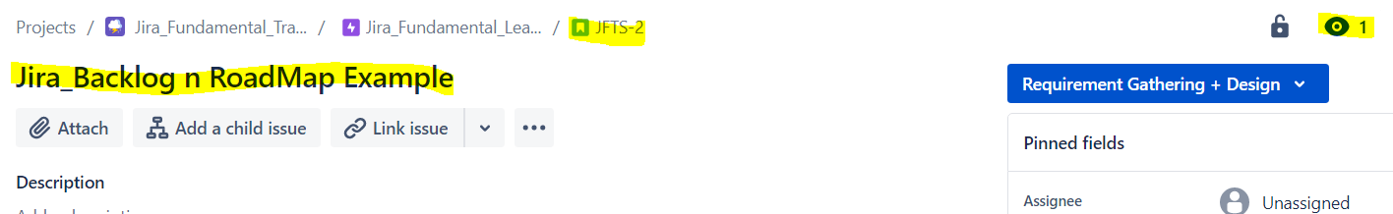

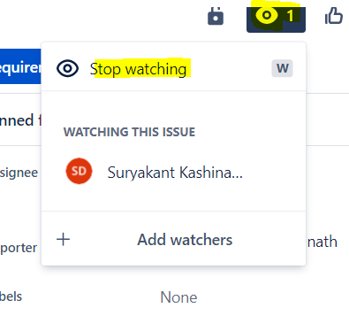

**2. Set the Jira homepage to 'Your work'**

Your default homepage may be set to the 'Project directory.' While this can be helpful at times, most users prefer to see the work assigned to them. To do this, set your homepage to 'Your work.'

**Why is this helpful?**It helps you find your work quickly and effortlessly. The 'Your work' screen shows items you've recently worked on or viewed. Recent projects, boards, and issues can all be found with a few clicks. Change the homepage to 'Your work,' and you'll never be too far from your most important projects and tasks.

👇 Here's how to change your Jira homepage.

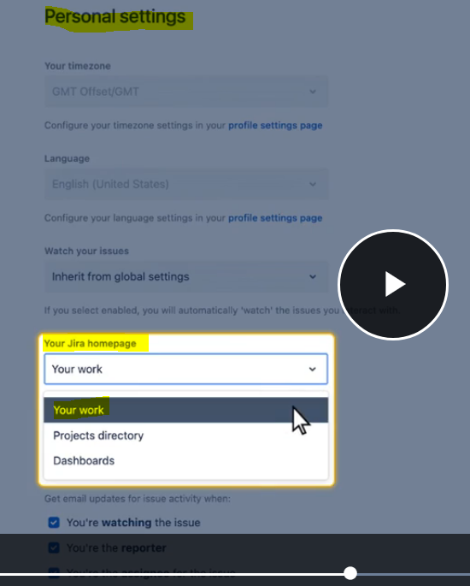

**3. Personalize your email preferences**

As you know, email is the best way to stay on top of your issues. Jira's default email settings are all-inclusive. You get emails for nearly any issue change. Each email has a direct link to the issue, making it easy to see and respond.

📩 In your personal settings, you can change the volume of emails you receive. If you prefer to receive fewer emails, uncheck the boxes for activities you're not interested in. You can always come back to your settings and update preferences as you wish.

**Our recommendation is to keep the email settings as all-inclusive as you can manage.**This will help you stay on top of your work. And keep you informed of work going on around you. If emails become unwieldy, try setting up an email filter. Scroll down to learn how.

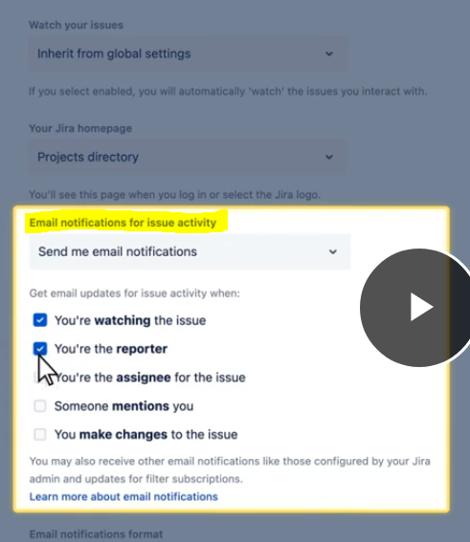

**4. Manage Jira emails with a custom email filter**

Okay, so this tip is going to take us on a brief detour outside of the world of Jira. But it's related to Jira emails, and most pro users find it extremely helpful.

If you feel you're receiving too many emails from Jira, set up a filter using your email client. Many users find email filters are a better way to manage Jira emails instead of changing their email preference settings. With a filter, you still get the important emails. But now, they're labeled, categorized, and not cluttering your inbox.

To set up an email filter, you'll need to do some light research to understand your email client. Know that the sender's email will always be [*jira@<yourinstance>.atlassian.net*](mailto:jira@%3Cyourinstance%3E.atlassian.net)

# Create simple views and dashboards

Jira gives you many ways to see your work: boards, backlogs, roadmaps, and others you'll learn soon. In previous courses, you learned the basics of these views. Now, you'll learn how to get the most out of them.

Applying these best practices will save you time finding and organizing work in Jira. You'll know exactly which view is best for every situation. And you'll be able to navigate to find the information you need.

Scroll below to learn the best practices for **seeing your work** in Jira.

**Tips to see your work in Jira**

**1. Use the board as your default view**

As you're using Jira each day, default to the board view. It is the most practical view, giving you a quick snapshot of all current and upcoming work.

**👉 Give this a try -**Filter to see only your issues. This feature helps you cut through the clutter and focus on your work only. To do this, select your profile icon above the board. Or select the 'Only My Issues' button.

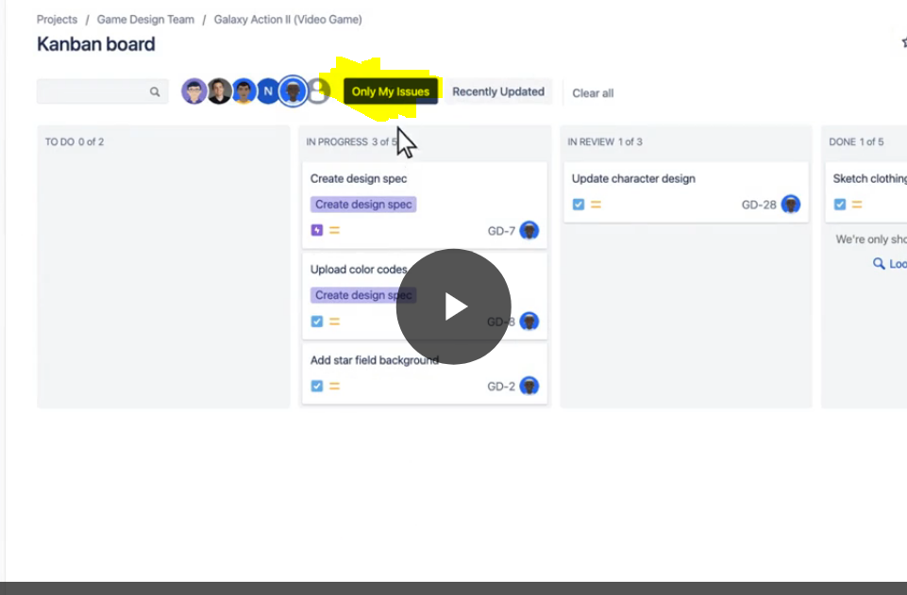

**2. Reorder your issues in the board view**

Take complete control of how your issues are organized on your board. Within a single board, drag and drop issues vertically to organize them as you wish. Just be careful not to move an issue to the next column until it's ready!

Some users prefer to organize their issues by date. Others prefer to organize by large initiative. Test out a few different strategies and see what you like.

**👉 Give this a try -**Find any column on your board and drag an issue above another issue to change its order.

**3. Save important searches as filters**

Jira's basic search feature allows you to save filters for future use. A filtergroups issues into a single view based on a set of search criteria. A saved filter can be shared with teammates, pulled as a report, or displayed in a dashboard (which you'll learn more about below).

**👉 Give this a try -** Save a search as a filter:

* Set your search specs and click ***'Search'***
* Near the top of the page, click ***'Save as'***
* Type a name for your filter and click ***'Submit'***

Once the filter is saved, you can share or export your filter by using the buttons at the top right of your screen.

**4. Use dashboards to see everything all at once**

A **dashboard** is a customized screen to give you a high-level snapshot of everything happening in Jira. Dashboards are made up of small configurable blocks called gadgets.

Your default dashboard may have gadgets like Introduction, Projects, Assigned to Me, and Activity Stream. Any gadget can be edited or deleted. The overall dashboard layout is entirely customizable.

You can create multiple dashboards for different projects. Or one single dashboard that spans all the work you're involved with.

👇 Here's an example of a Jira dashboard.

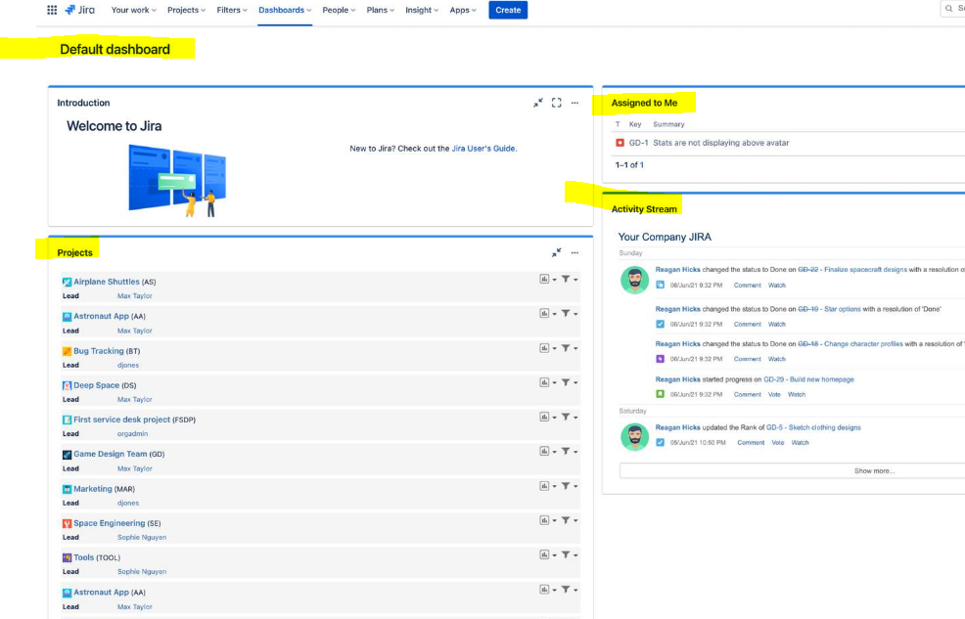

**How to create your own dashboard**

**Step 1 - Create a new dashboard**

* On the main navigation bar, select ***Dashboards*** >***Create dashboard***
* Give your dashboard a name and description and select***Save***

**Step 2 - Add your gadgets**

Gadgets are the building blocks of your dashboard. There are dozens of gadgets to choose from. Here's how to add gadgets to your dashboard:

* At the top right of your window, select ***Add gadget***
* Scroll through the available gadgets and select ***Add gadget***

**⭐ What are the most popular gadgets for users?**It depends on how you use Jira. If you're not sure where to start, here are the four gadgets we recommend.

* **Issues in progress:**Shows all your issues currently in progress.
* **Assigned to Me:**Shows all unresolved issues assigned to you.
* **Activity Stream:**Shows recent activity across your entire project.
* **Created vs. Resolved Chart:** Shows a charted comparison of created issues and resolved issues to give you a sense of your workload.
* **Step 3 - Organize your gadgets and test your dashboard**
* Just like that, your new dashboard is ready to go. You can organize your gadgets by dragging and dropping them where you wish. If you find a gadget that isn't useful, delete it and add a new one.
* Many gadgets require you to set up filters before they can be used properly. You'll learn more about filters and dashboards in future courses. But, for now, take some time to get familiar with the basics and test it out yourself.
* Every new dashboard is only visible to you. So feel free to explore new gadgets and filters to get the information you need.

# Connect Jira with other tools

Slack, Microsoft, Zoom, Google, and thousands more. Jira can integrate with 3,000+ tools to help improve your productivity and efficiency. Today we'll cover some of the most popular integrations to help optimize your Jira experience.

Here are the best practices for **connecting Jira with other tools.**

**Tips to connect Jira with other tools**

**1. Integrate with Confluence to better manage projects**

The easiest (and most recommended) tool to connect with Jira is [Confluence](https://www.atlassian.com/software/confluence), another Atlassian product. Confluence is a remote-friendly workspace to help your team build pages and manage information.

Connecting Jira and Confluence creates one place for your team to build, organize, and collaborate on work. 76% of Jira Software customers say they shipped projects faster after adding Confluence to help organize and manage agile projects.

If your team isn't using Confluence yet, it's worth a try. It'll make a world of difference to help manage your projects.

**2. Integrate with Slack for simpler communications**

Connecting Jira and Slack gives you real-time insight into your Jira projects. This integration helps you and your team be aware of any issue changes the second they occur.

Instead of email notifications, this integration sends you Slack notifications when issues are created or updated. Connect Jira projects to Slack channels, so your entire team gets updates. Plus, you can create new issues directly from Slack.

If your team is already using Slack, the Jira add-on is an easy way to keep your work organized and in sync.

**3. Integrate with Microsoft for smooth collaboration**

Jira's integration with Microsoft Teams works wonders. This integration simplifies backlog collaboration and communication across your team. Within the Microsoft Teams tool, you can easily create tabs with issues. Plus, track and discuss your team’s progress directly in your channel.

If your team is already using Microsoft Teams, the Jira add-on is a simple way to keep your work and communications together. Note that for this integration, you will need administrator access.

**4. Integrate with Zoom to start meetings from any issue**

Rather than toggling between calendars, the Zoom integration allows you to schedule video meetings directly from any issue. Every watcher of the issue will be automatically added to the invite. And the meeting links and details will be added to the issue comments. Record a video meeting, and the file and transcript will also be in the Jira comments.

If your team is already using Zoom, the Jira add-on is a helpful way to connect your work tasks with face-to-face communications.